**Standard Operating Procedure**

|  |  |  |  |
| --- | --- | --- | --- |
|  | NAME | SIGNATURE | DATE |
| Author |  |  |  |
| Reviewer |  |  |  |
| Authoriser |  |  |  |

|  |  |  |
| --- | --- | --- |
|  | Effective Date: |  |
|  | Revision |  |
|  | Code: |  |

|  |  |  |  |
| --- | --- | --- | --- |
| READ BY | | | |
| NAME | TITLE | SIGNATURE | DATE |
|  |  |  |  |
|  |  |  |  |
|  |  |  |  |
|  |  |  |  |
|  |  |  |  |
|  |  |  |  |
|  |  |  |  |

How to access image file 10.png

-

Implement Stripe Checkout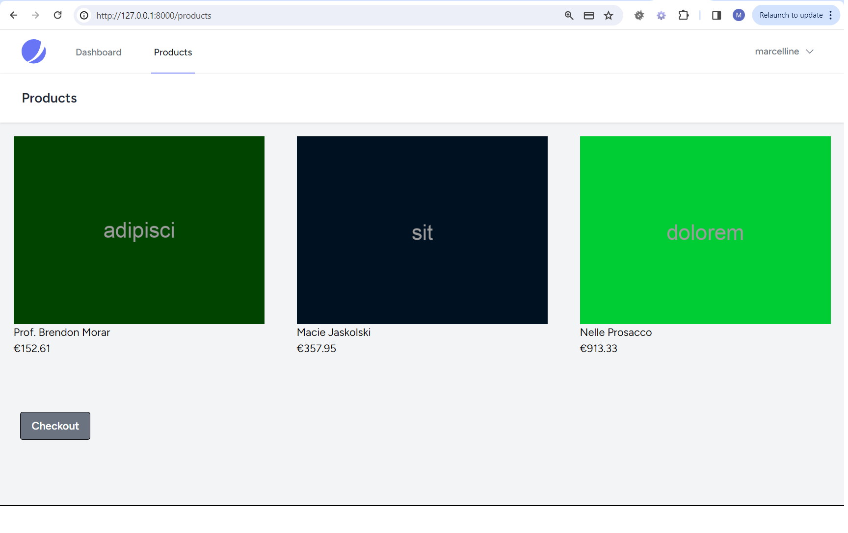 6

Create a Stripe Account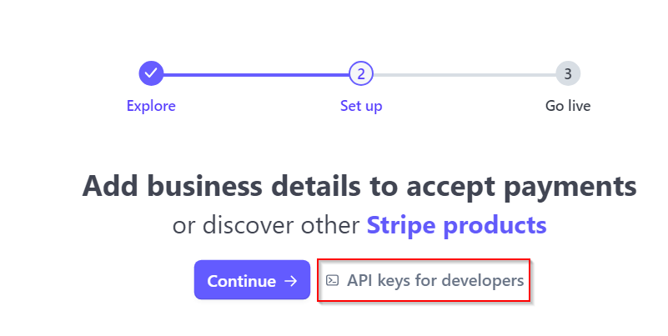 9

Test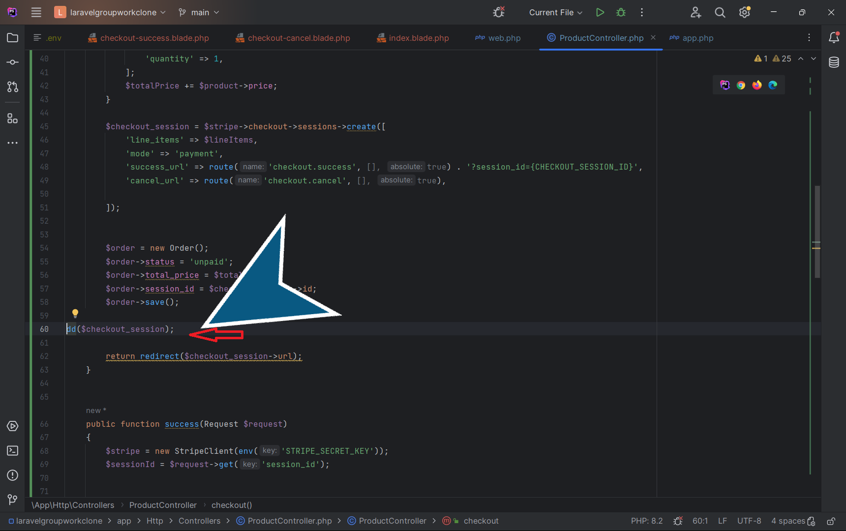 13

Test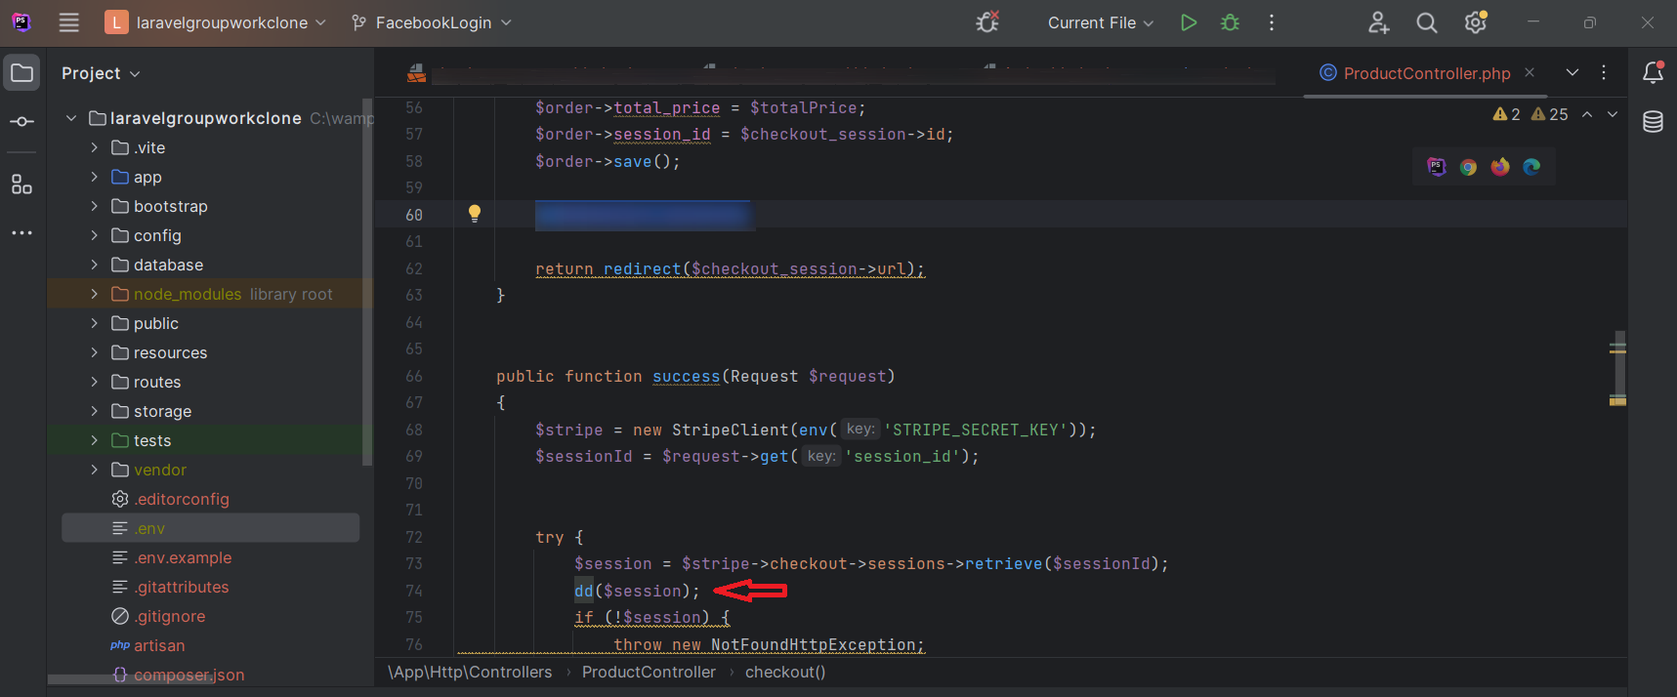 15

Test the checkout process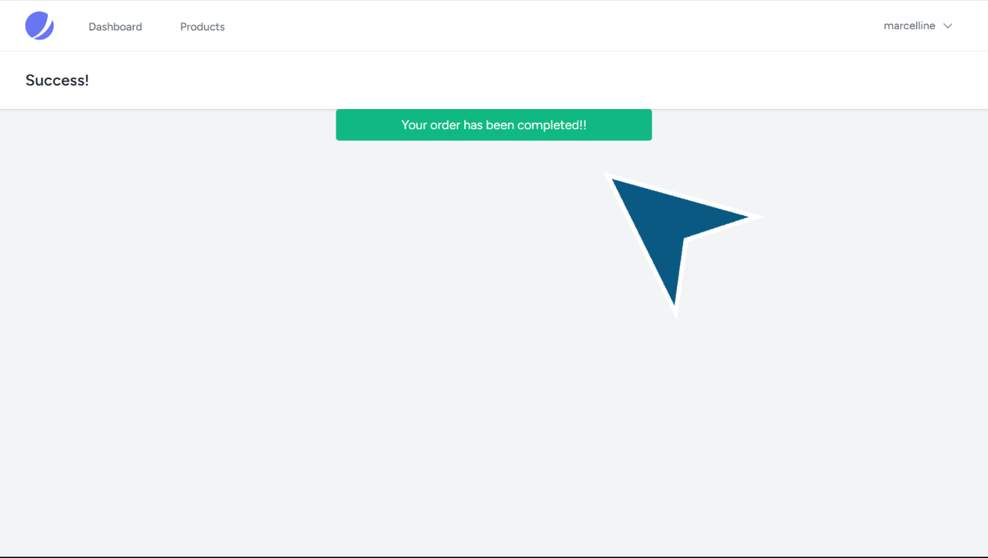 19

The necessity of webhooks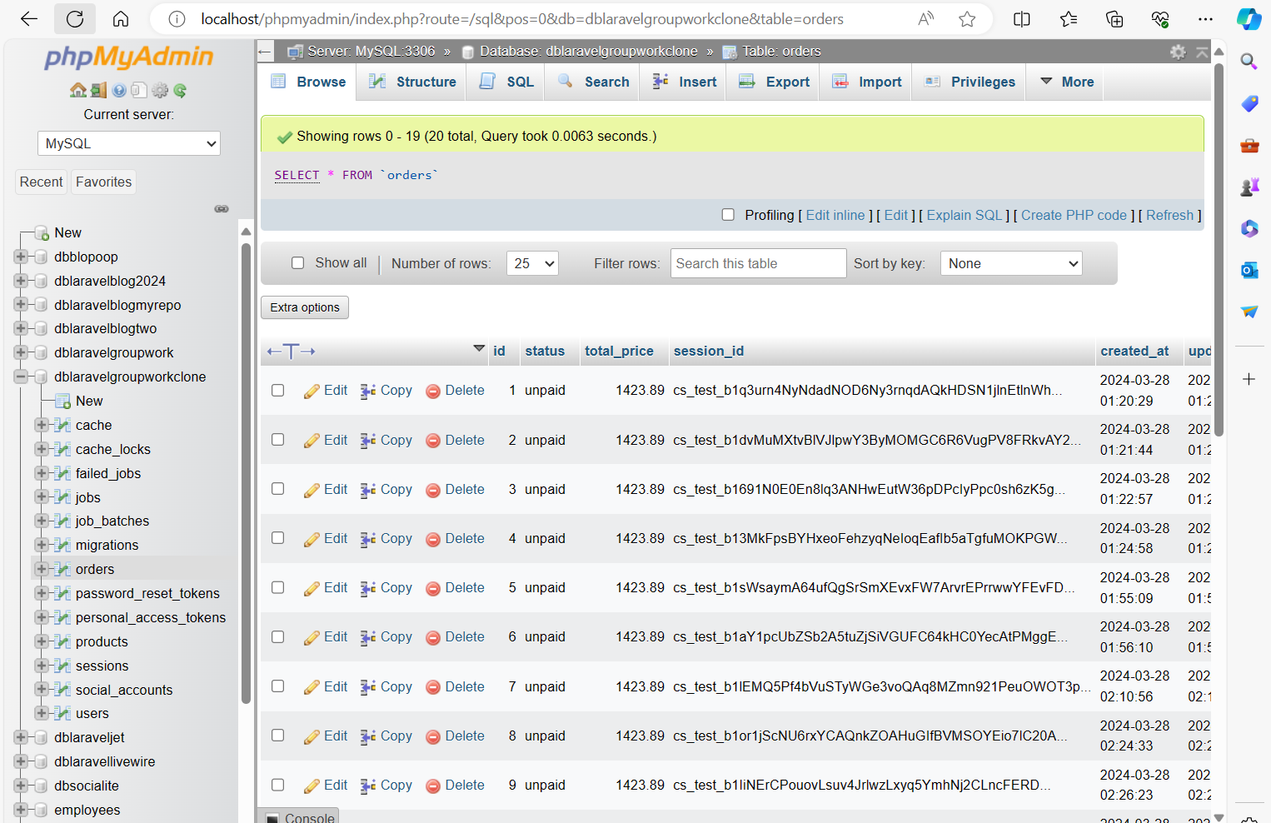 20

Test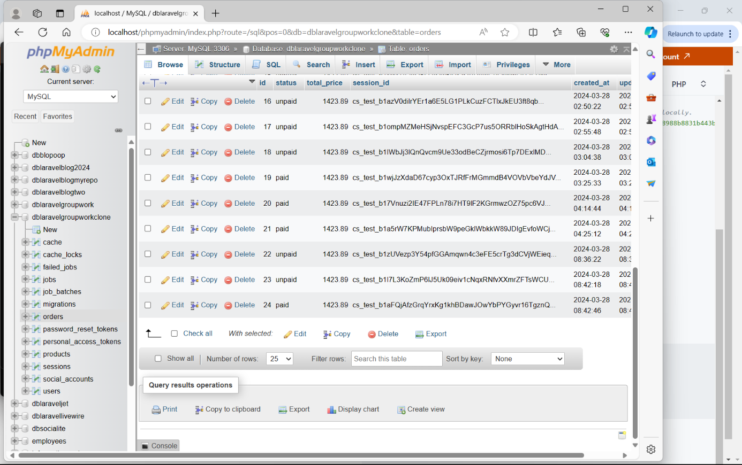 36

# Implement Stripe Checkout

1. Start point. Product page.

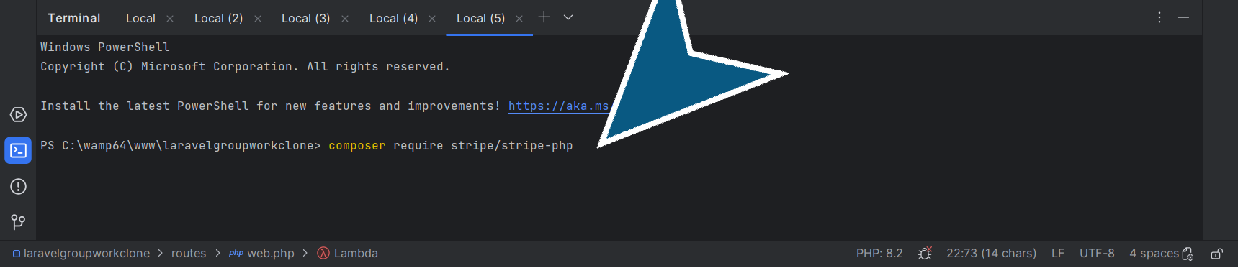

2. In PhpStorm, Install Stripe php package.

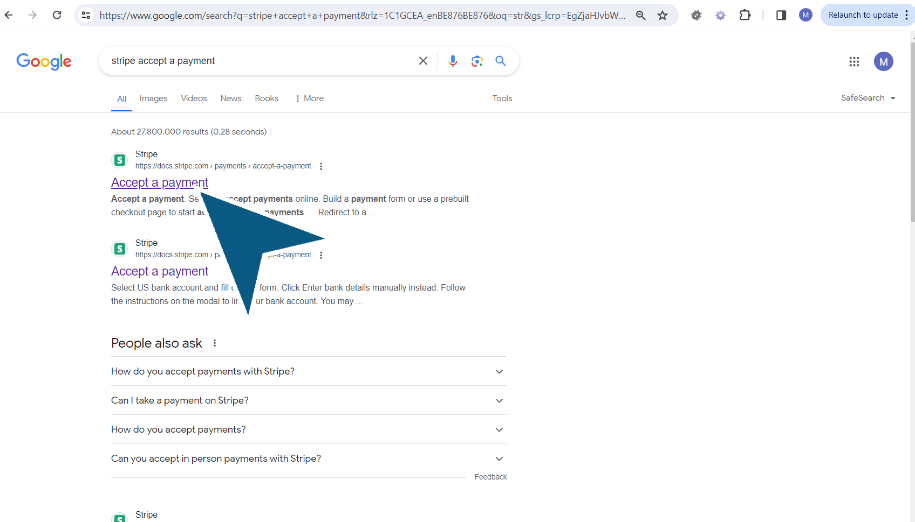

3. Now, go to Google.com and search for “stripe accept a payment”. It's the documentation of Stripe.

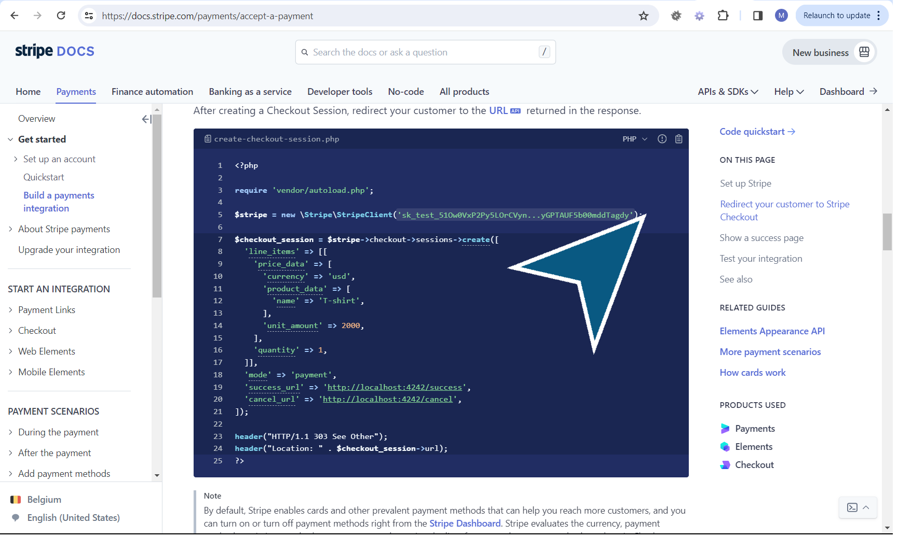

4. Copy the code to set the API key and the checkout session. And paste it in the ProductController.

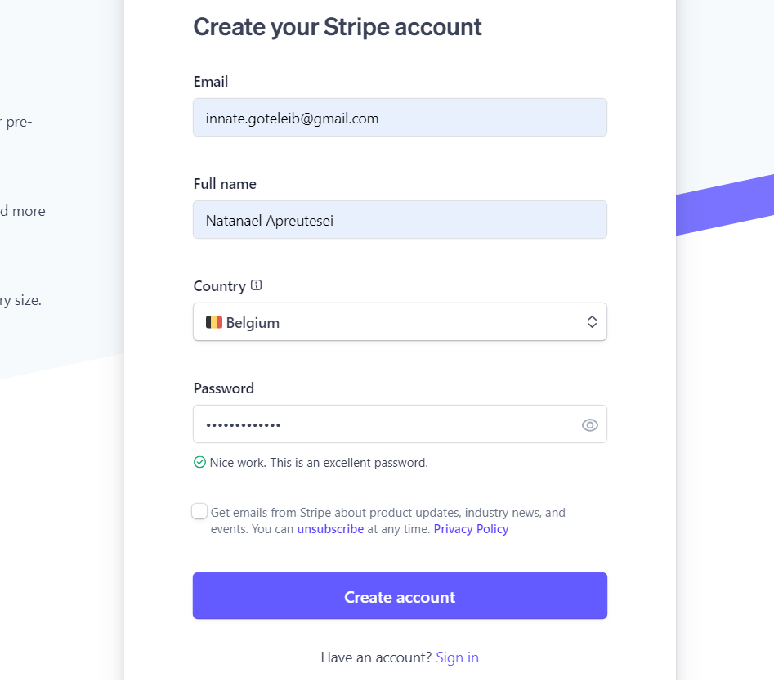

5. 1. Go to stripe.com and register as a new user 2. Verify your email to be able to use Stripe 3. After verification, click on "Activate payments". 4. Choose Belgium and Natuurlijke persoon 5. Then, since we going to use Stripe in test mode and you don't need to fill any other information, close the tab.

# Create a Stripe Account

6. 6. Then on dashboard page, click on API keys for developers. 7. On this page you will find the public and secret key to add to your project.

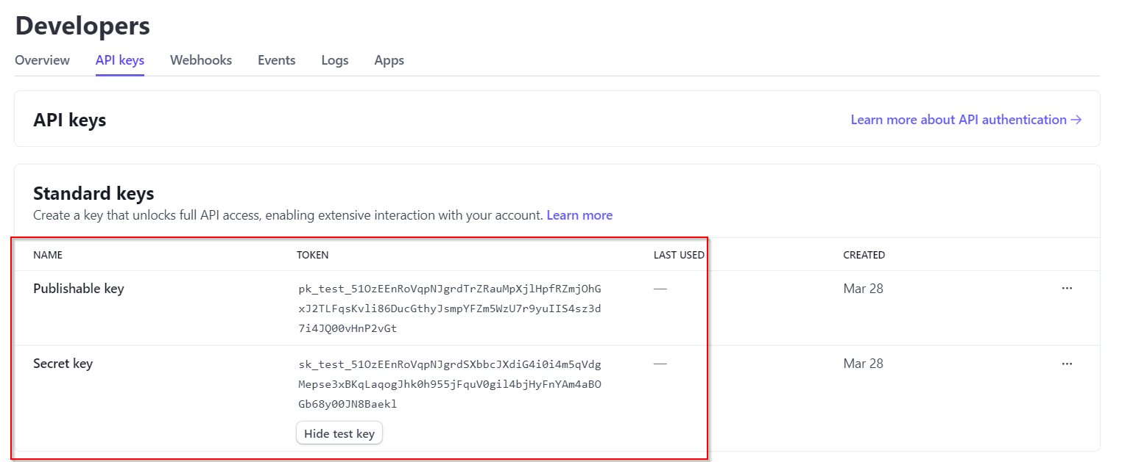

7. Click on API keys to access the Stripe Secret key

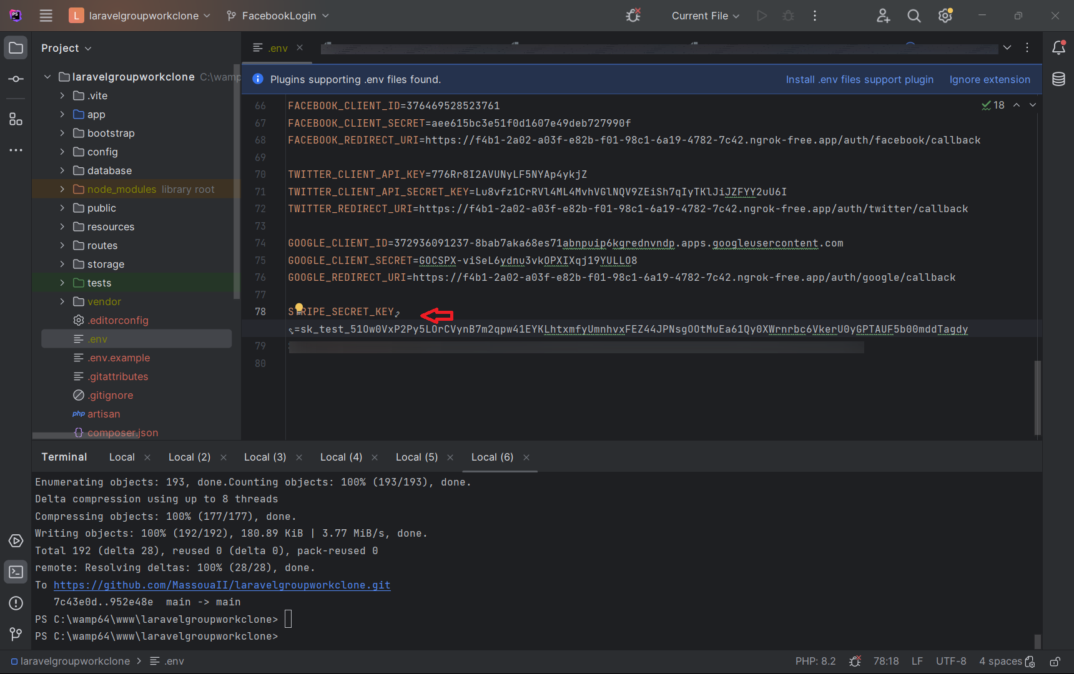

8. Open the .env. file and paste the Stripe Secret key

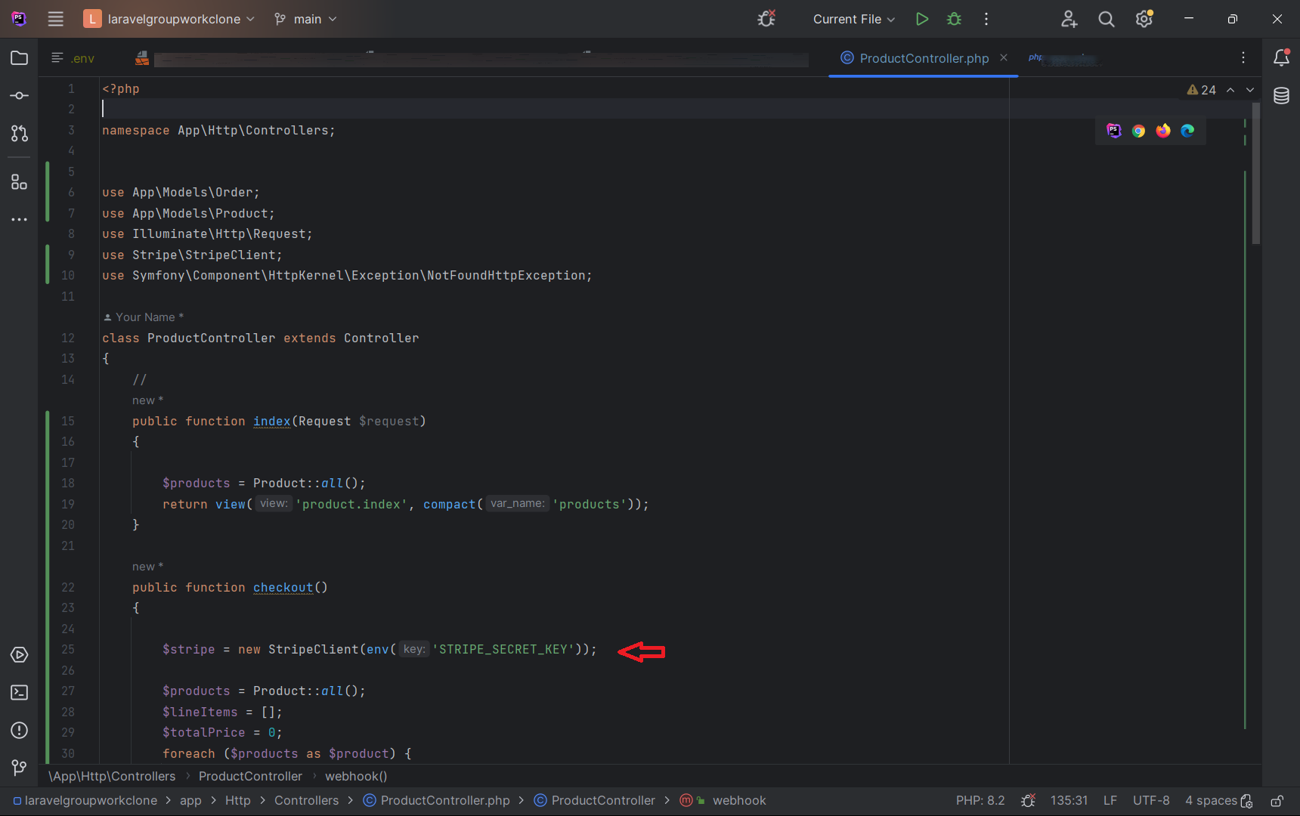

9. In ‘ProductController.php’. The public function index provides the products that will be checked out.  
In the public function checkout, paste the code you retrieved from Stripe docs and remove the example key. Replace that key with the env. code.

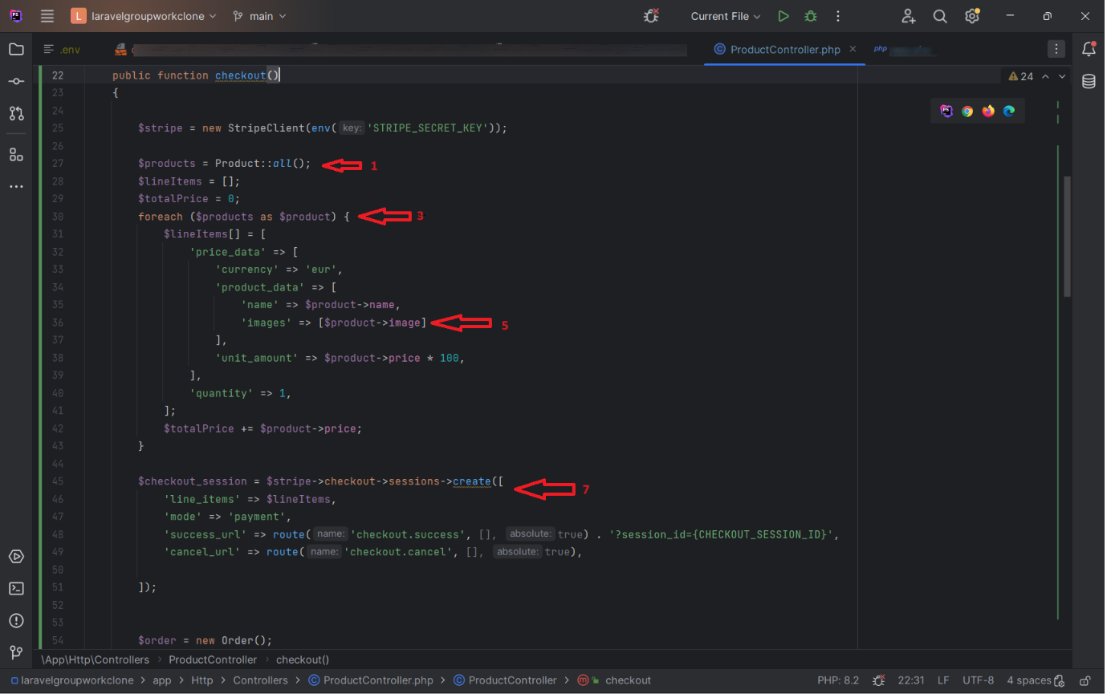

10. In ‘ProductController.php’,

1. provide again all the products.

2. The products will be checked out with line items as an empty array.

3. Add the total price as 0.

4. Iterate over the products.

5. Specify the line items in the array.

6. Add images.

7. Create a session. The session contains the success and the cancel urls.

8. Configure the names and arguments of the success and cancel urls according to web.php routes.

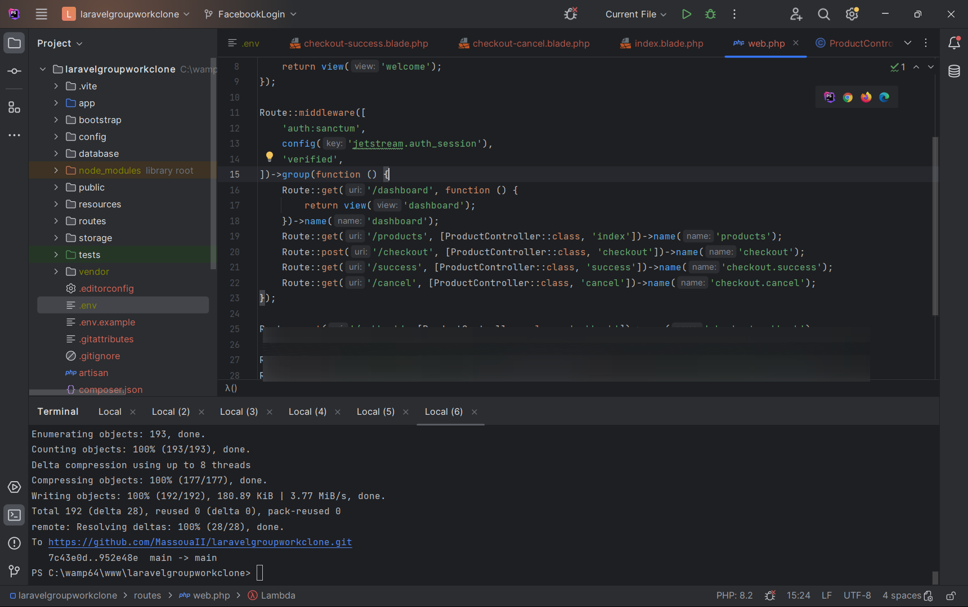

11. In ‘ web.php’.,

Create the routes for success and cancel functions.

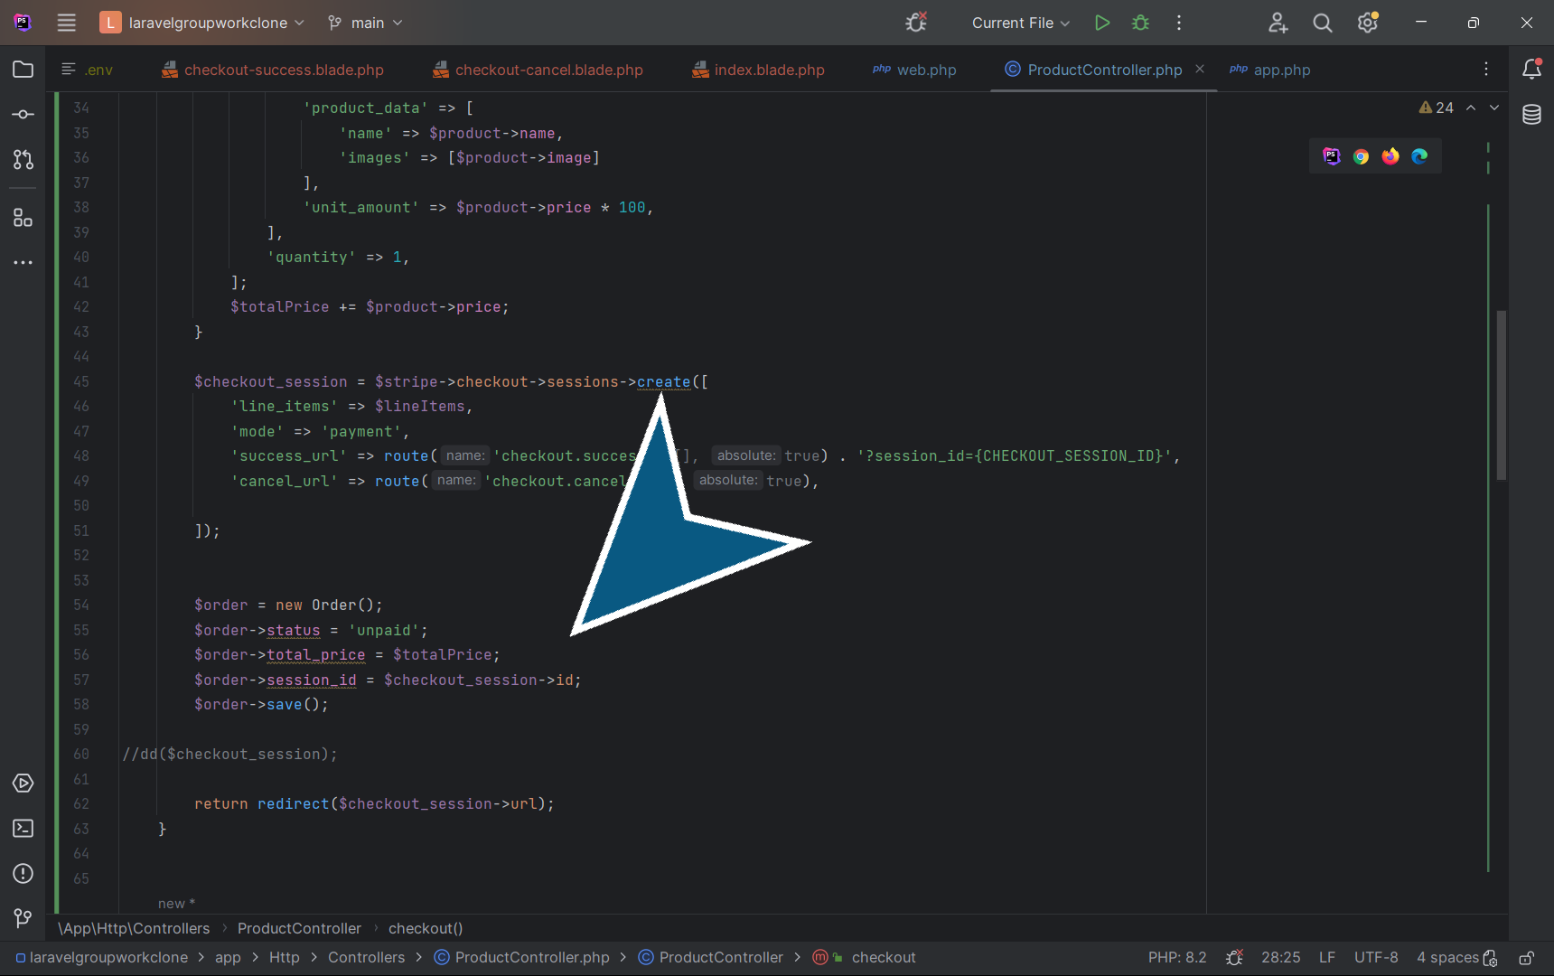

12. In ‘ProductController.php’.,

1. Create an order.

Explanation: We have prepared the data (products), we created a session and Stripe returned session. Now we have to take the session Id and save it in the database and associate it to the order.

2. Add the details of the order (status, total_price, session_id) before redirecting the user to the session URL.

# Test

13. In ‘ProductController.php’.,

1. If we dd the checkout session, we

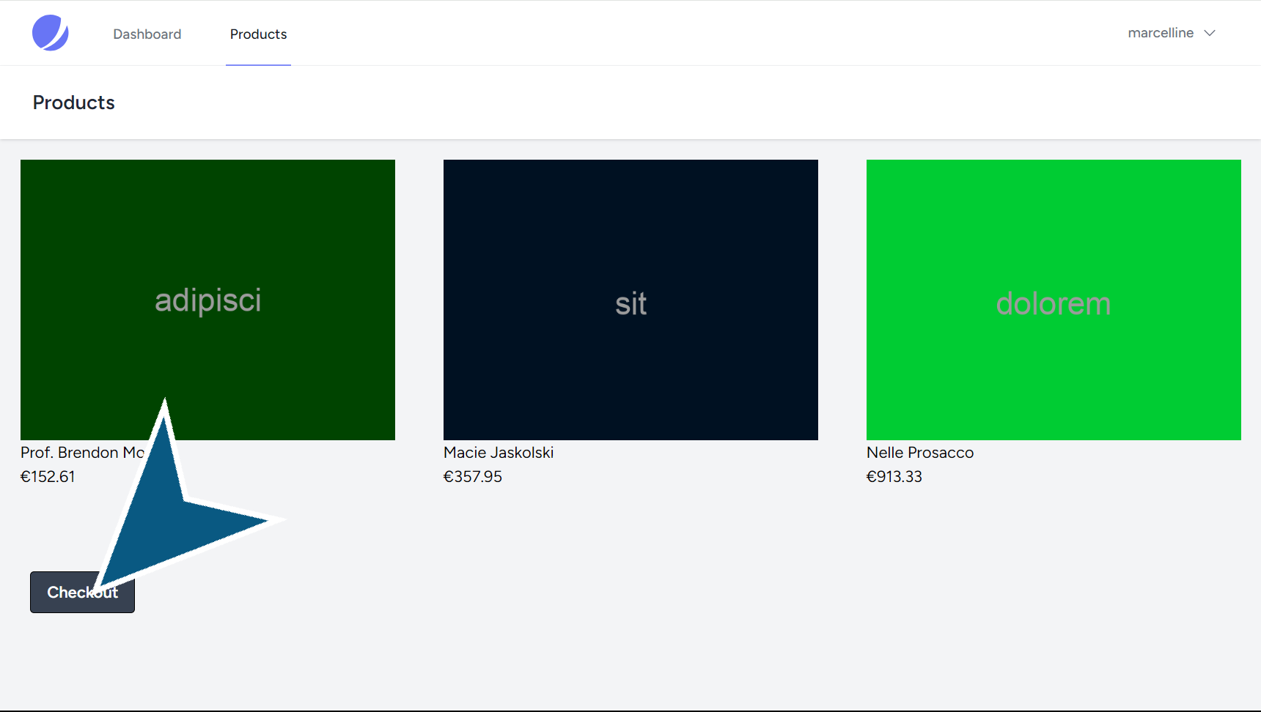

14. On the products page,

Click ‘Checkout’.

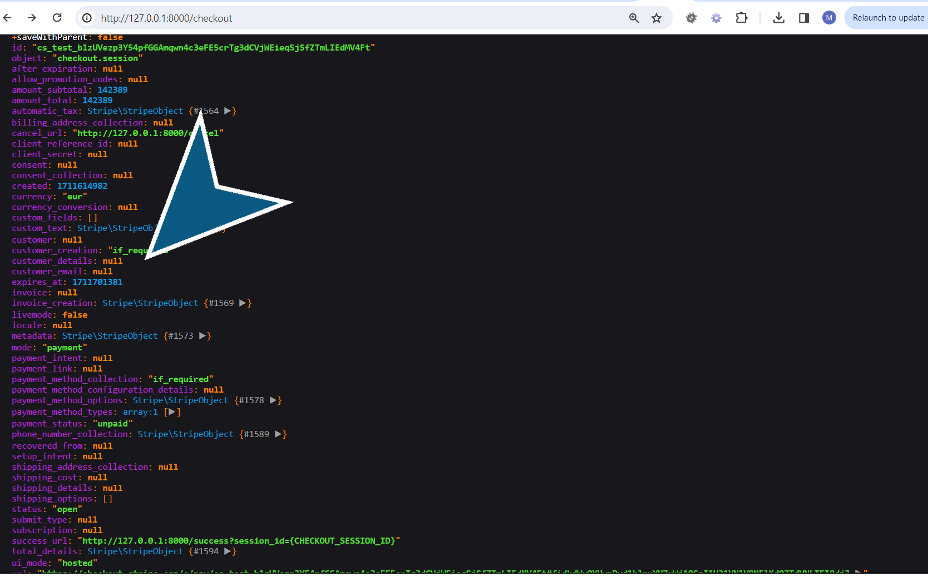

15. The checkout session does not give any details on the customer and the payment status is 'unpaid'.

# Test

16. In ‘ProductController.php’.,

1. Remove the dd ($checkout_session)

2. Put a dd($session)

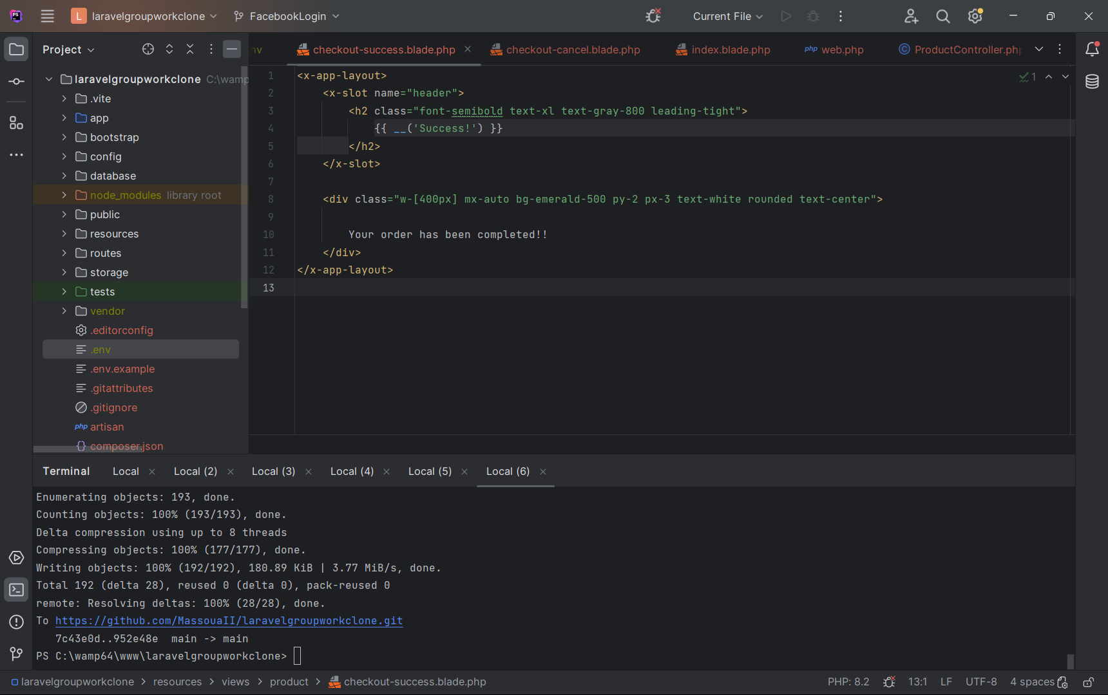

17. Click ‘laravelgroupworkclone – checkout-success.blade.php’.

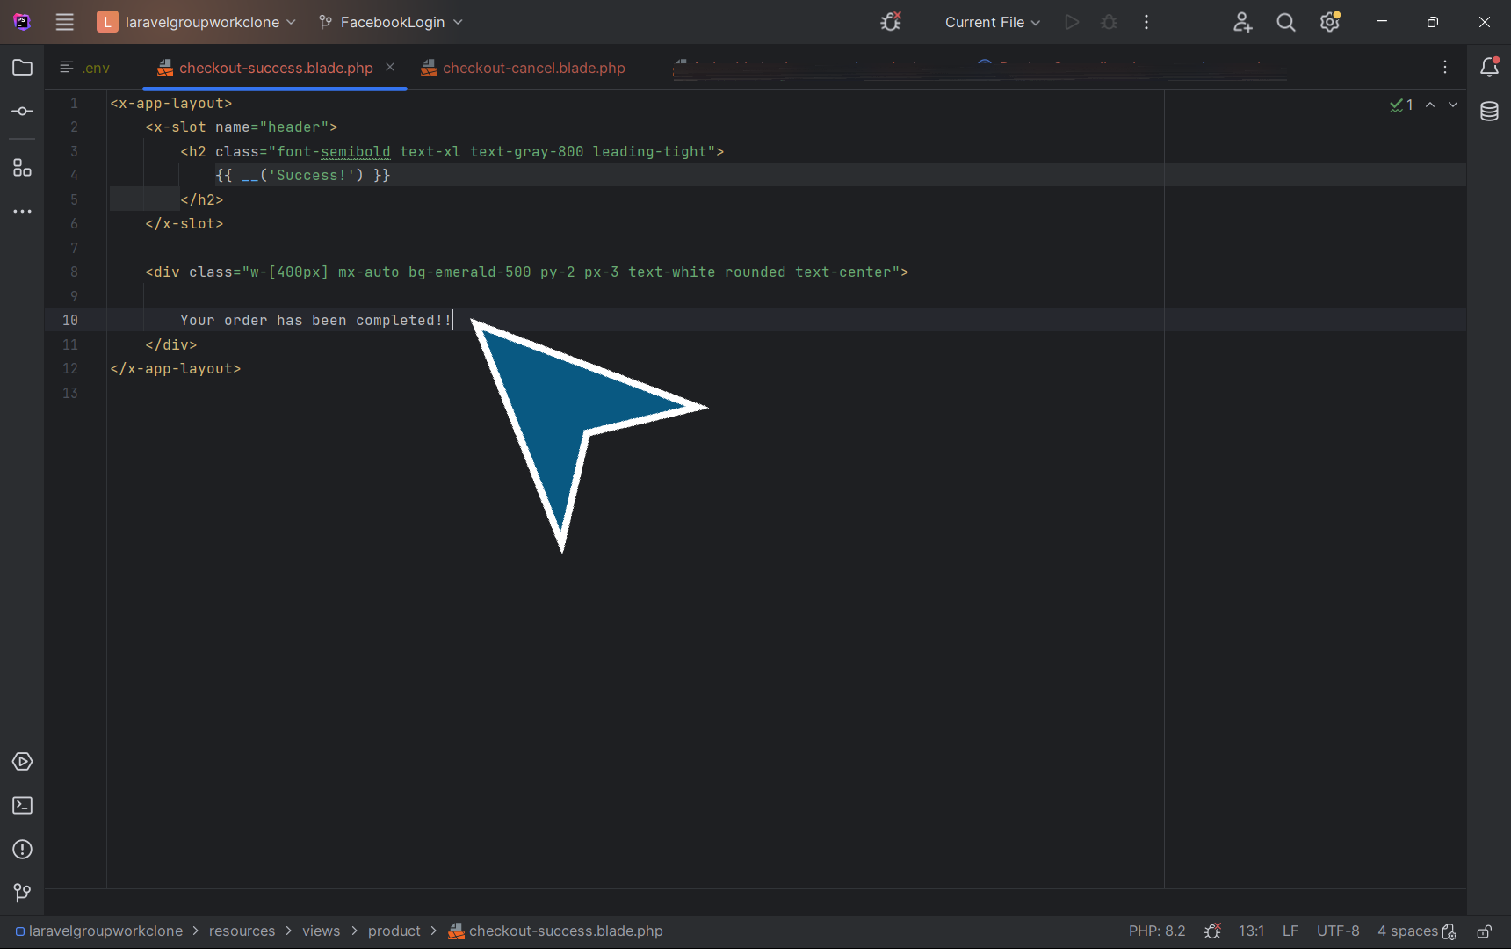

18. Create the view page in the resources/product folder, ‘checkout-success.blade.php’ with a success messsage, and ‘checkout-cancel.blade.php’ with a failure message.

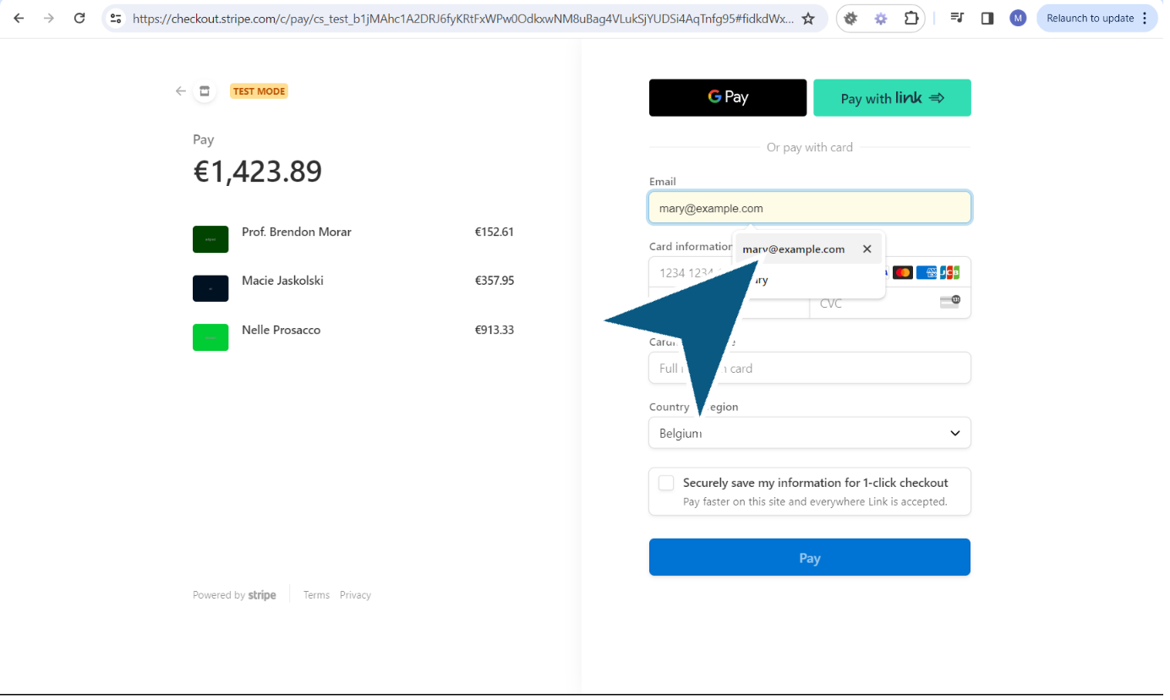

19. 1. On the products page,

2. Click again on ‘Checkout’.

You are redirected to the Stripe checkout page.

Fill in the card info, specify the email, the cardholder name.

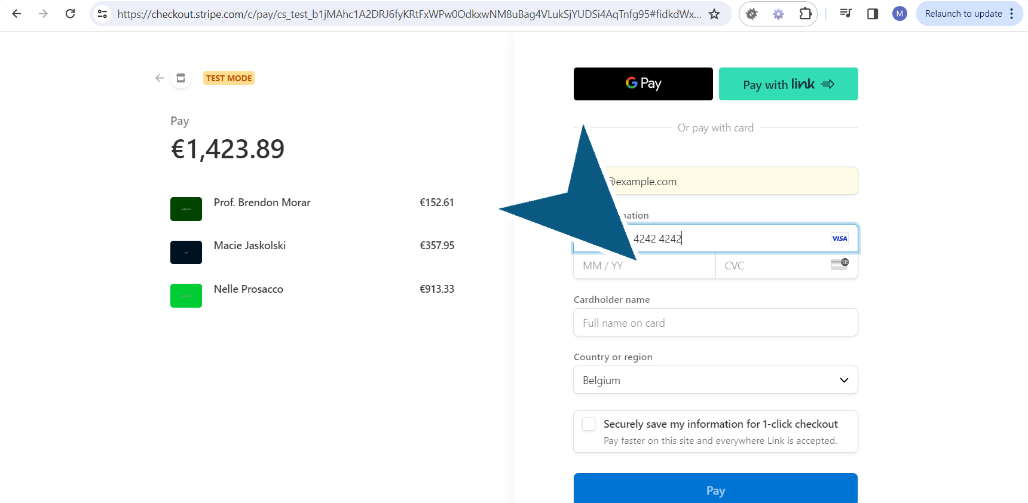

20. Also fill ‘Expiration’ date and CVC.

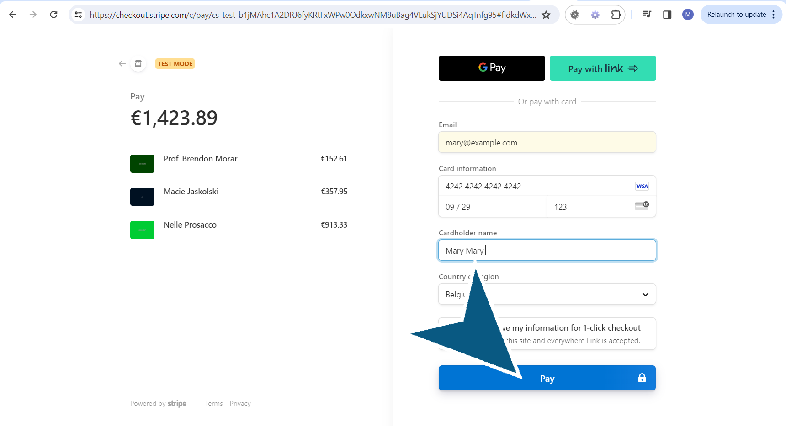

21. Click the ‘Pay’ button.

You will be redirected to the checkout.success page.

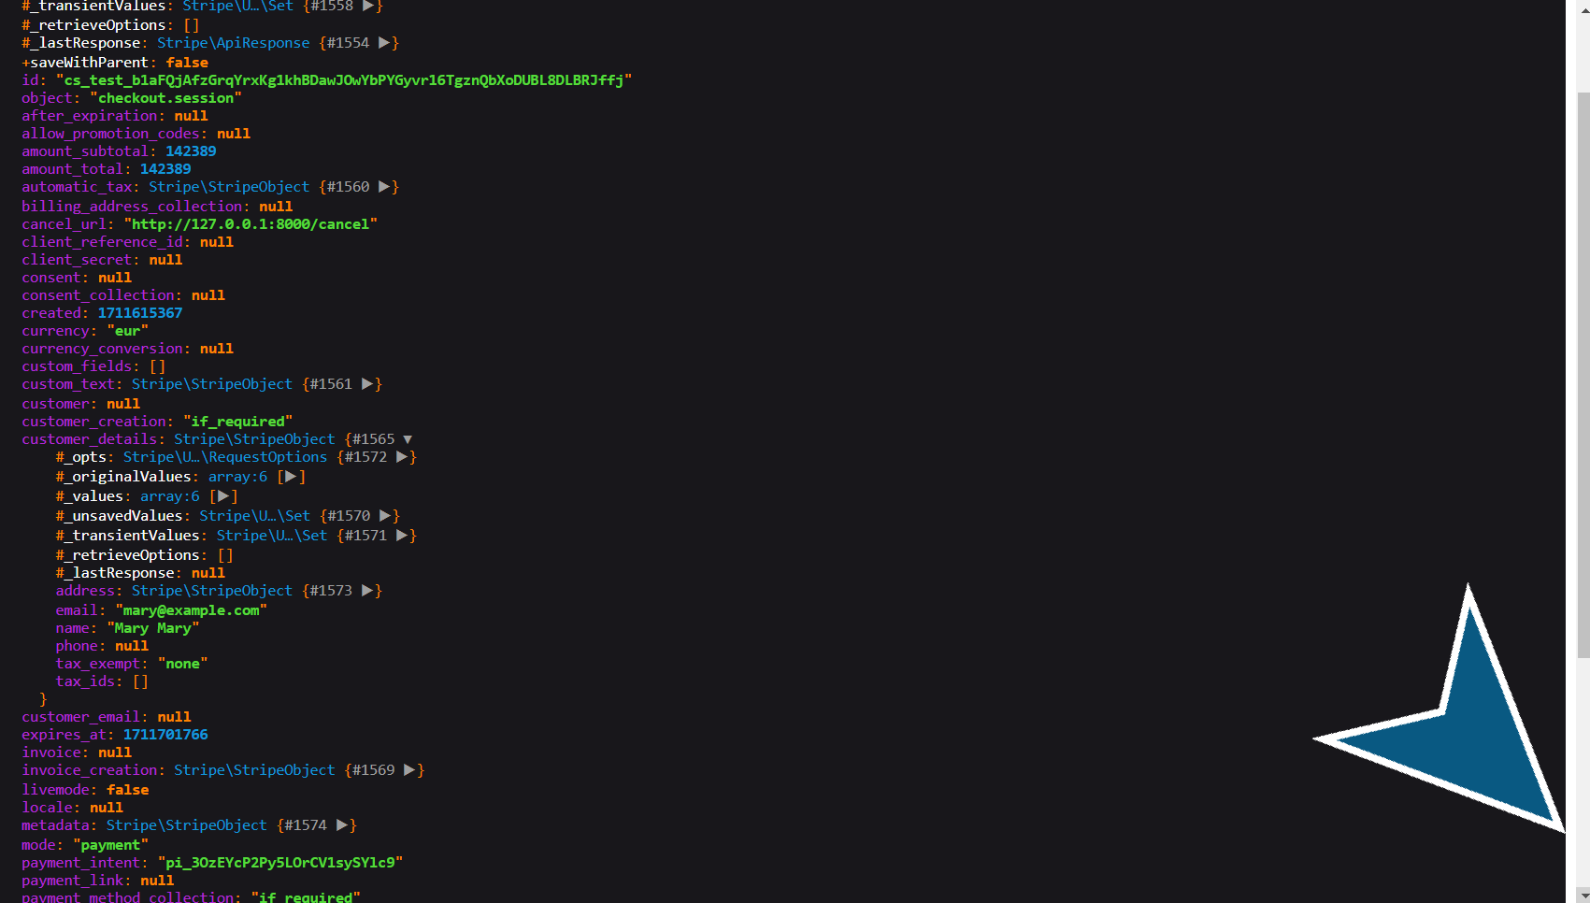

22. Because we dd the session, the customer's details are now visible and the payment_status is 'paid'.

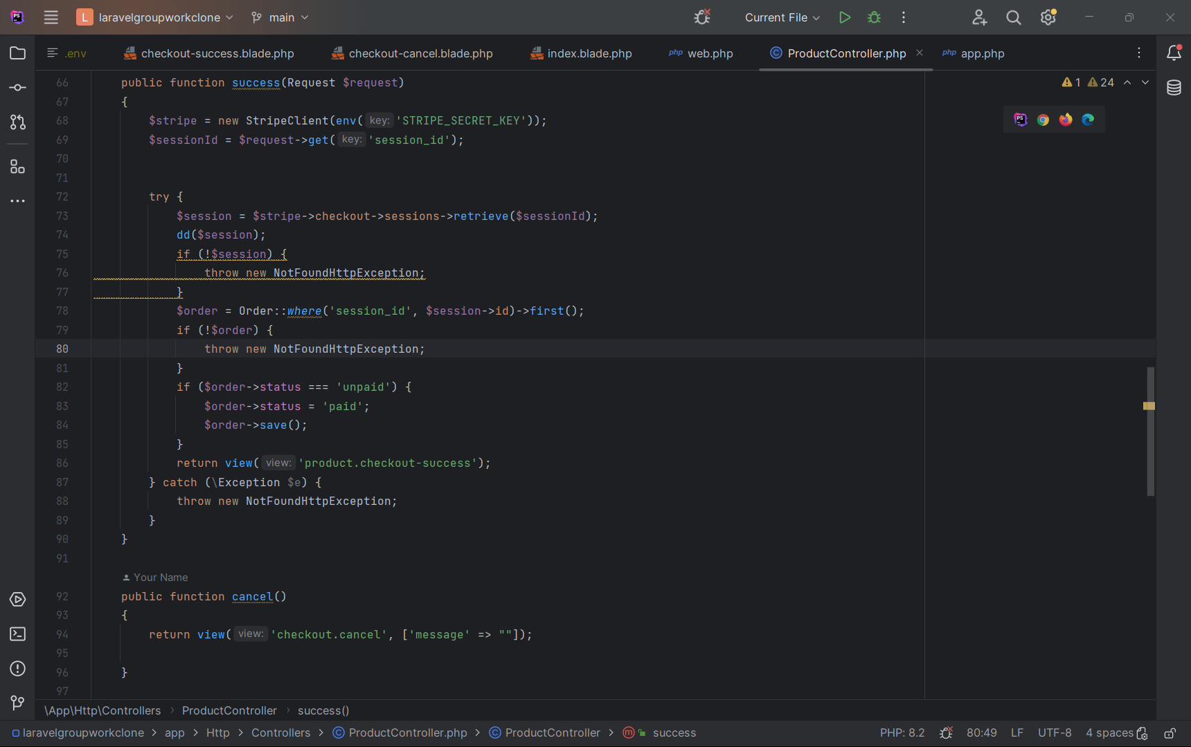

23. In the ‘ProductController.php’.,

1. Add a return view success to the success function

2. Stripe gives the possibility to customize the session Id ad append it to the success url route.

3. If the session does not exist, a not found exception is thrown, BUT if the session Id is invalid, it's also going to thrown an exception error.

4. To update the order, take the session_id to identify the order in the database. Select the order which is unpaid and change the status into paid. Then save the order

# Test the checkout process

24. 1. On the products page,

2. Click again on ‘Checkout’.

You are redirected to the Stripe checkout page.

Fill in the card info, specify the email, the cardholder name.  
3. You are redirected to the success page, and the success message is displayed.

# The necessity of webhooks

25. The ideal scenario is: You click on checkout, to process the order, you are redirected to the stripe page and the card info are filled out. You click pay and when the button turns green, it means the money has been taken from the customer's account and he received a message on screen.

But if the redirect doesn't happen in the browser, the order will stay unpaid.

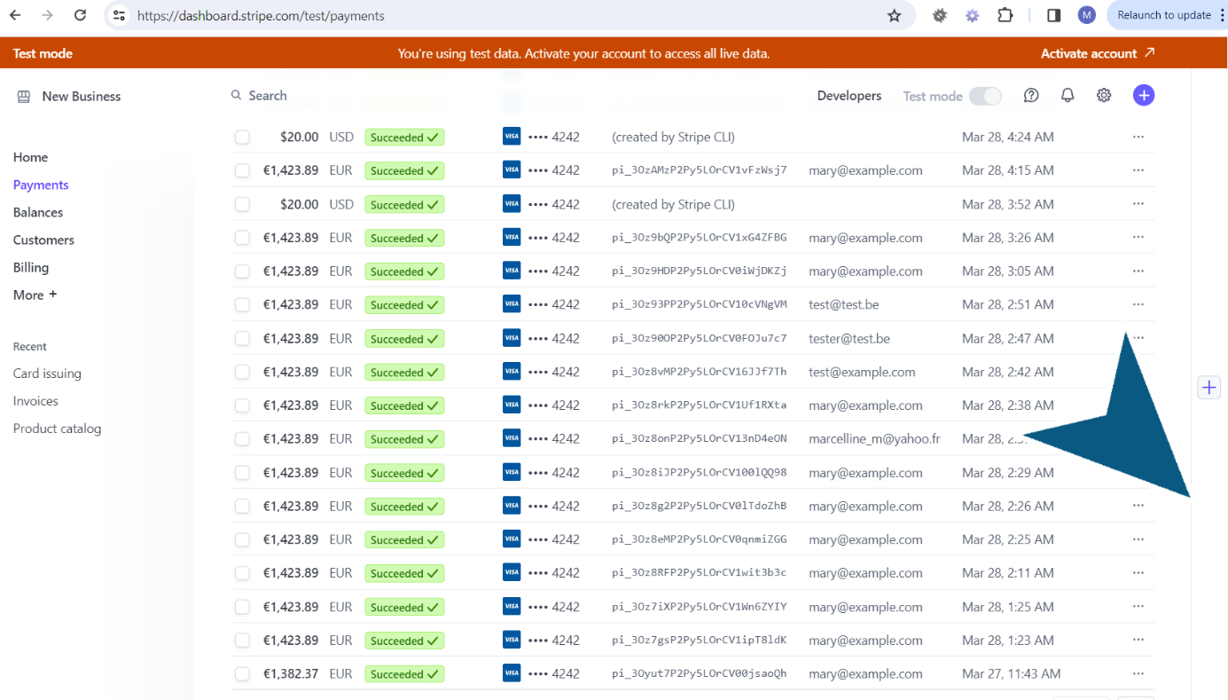

26. The ideal scenario is: You click on checkout, to process the order, you are redirected to the stripe page and the card info are filled out. You click pay and when the button turns green, it means the money has been taken from the customer's account and he received a message on screen.

But if the redirect doesn't happen in the browser, the order will stay unpaid.

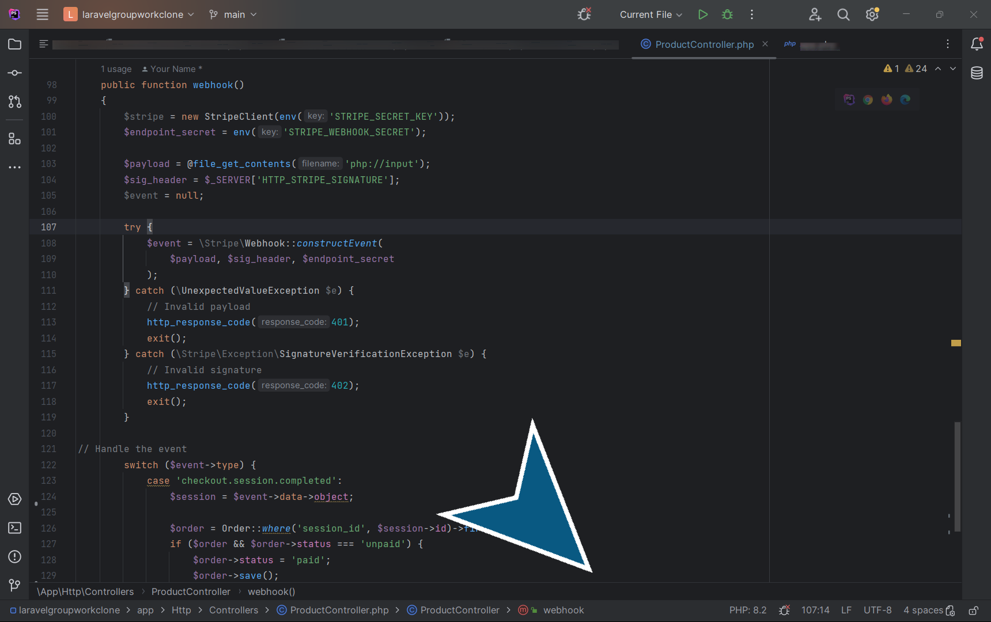

27. Stripe supports webhooks. Webhooks are http requests that are sent to the server for certain types of events. One of them being the checkout.

In ‘ProductController.php’. ,

To define the webhook url,

1. Create a public function webhook with the following code taken from Stripe docs at <https://dashboard.stripe.com/test/webhooks/create?endpoint_location=local>

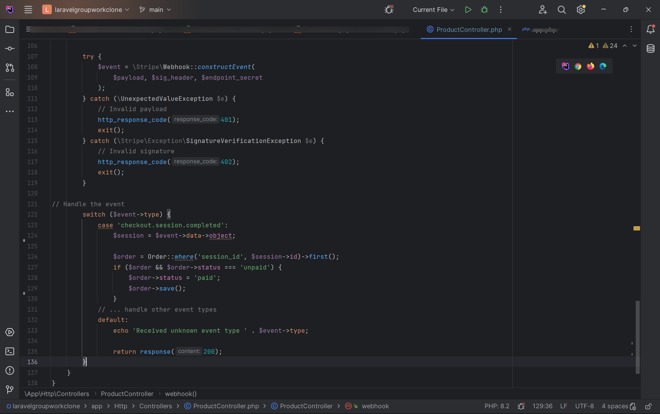

28. In ‘ProductController.php’.,

Complete the code for the webhook function. In this code, we read all the input coming, and construct an event based on the payload, signature header and endpoint secret. The return response is an empty string with code 200. When an errors happens it returns the status 401 or 402.

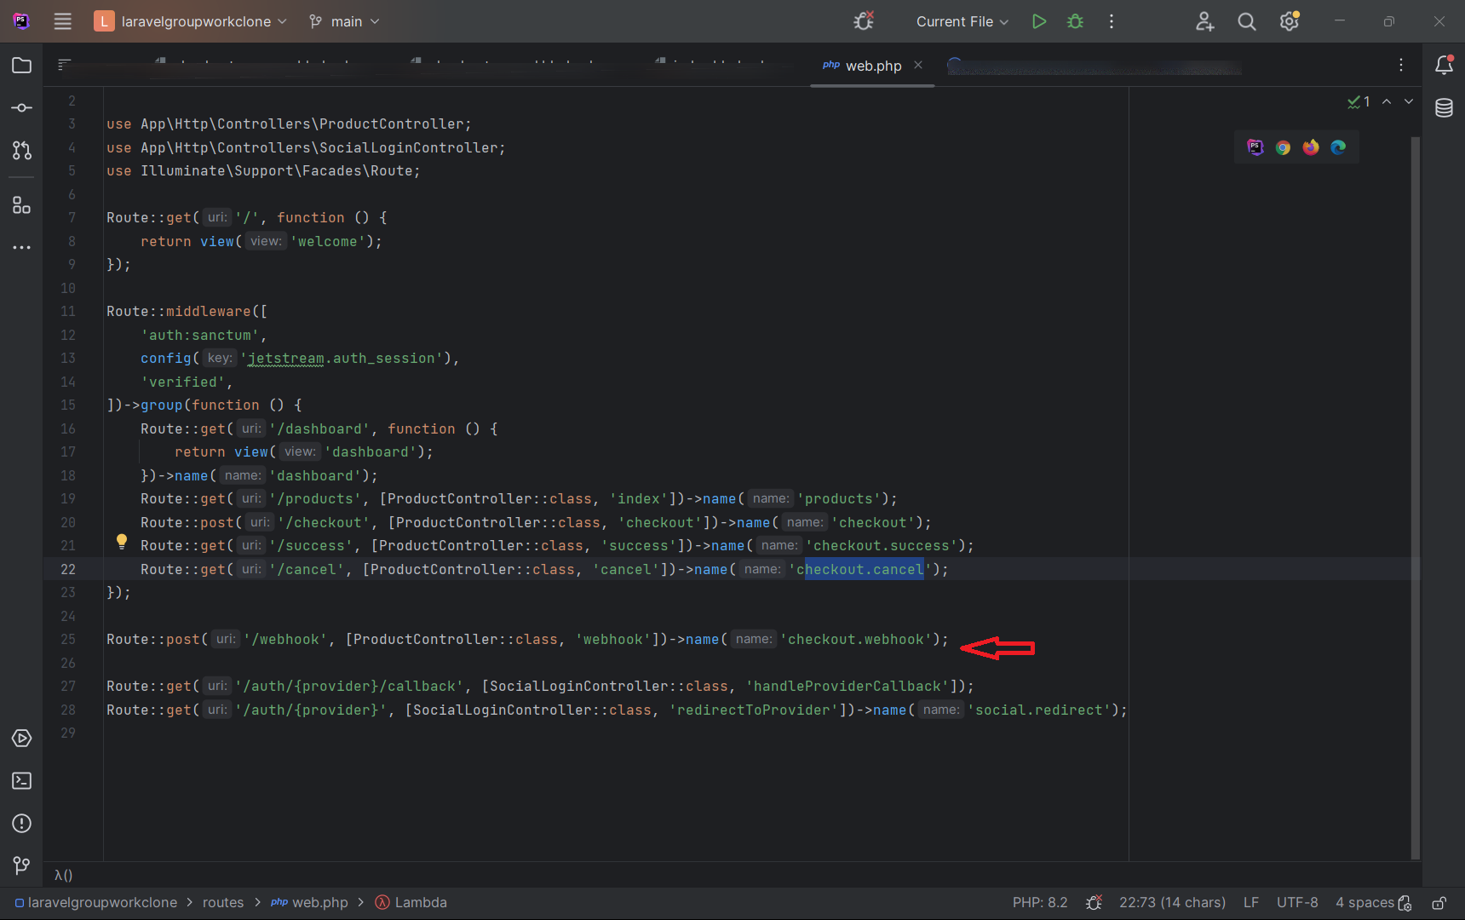

29. In ‘ web.php’.,

1. Create a route for webhook with a request method 'post'.

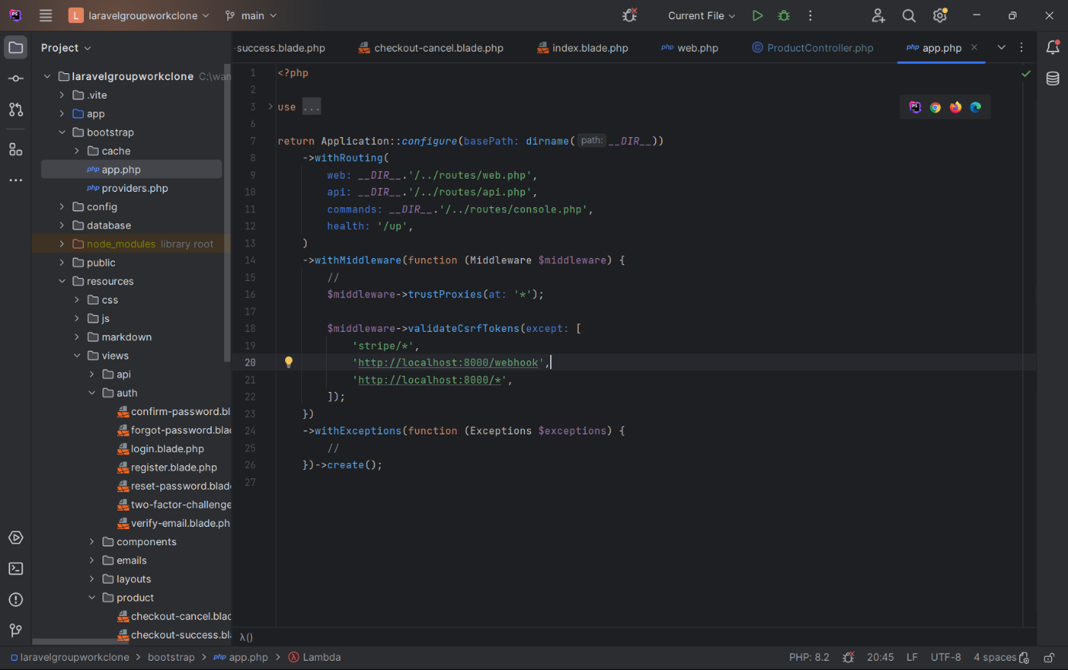

30. Because the request is coming from Stripe, we will have a csrf validation problem if we don't disable csrf for this url.

In bootstrap/ ‘app.php’.,

1. Copy the code below to disable the csrf Tokens.

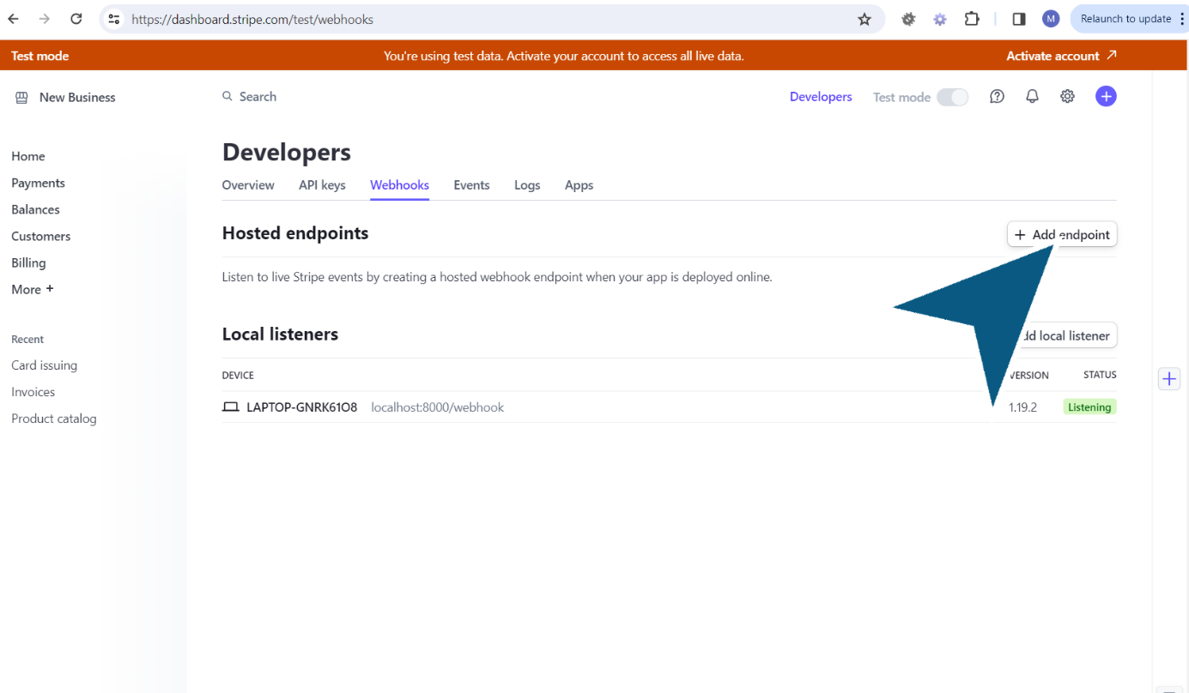

31. To listen to Stripe events,

1. Go to webhooks in the developer dashboard and click on ‘Add endpoint’.

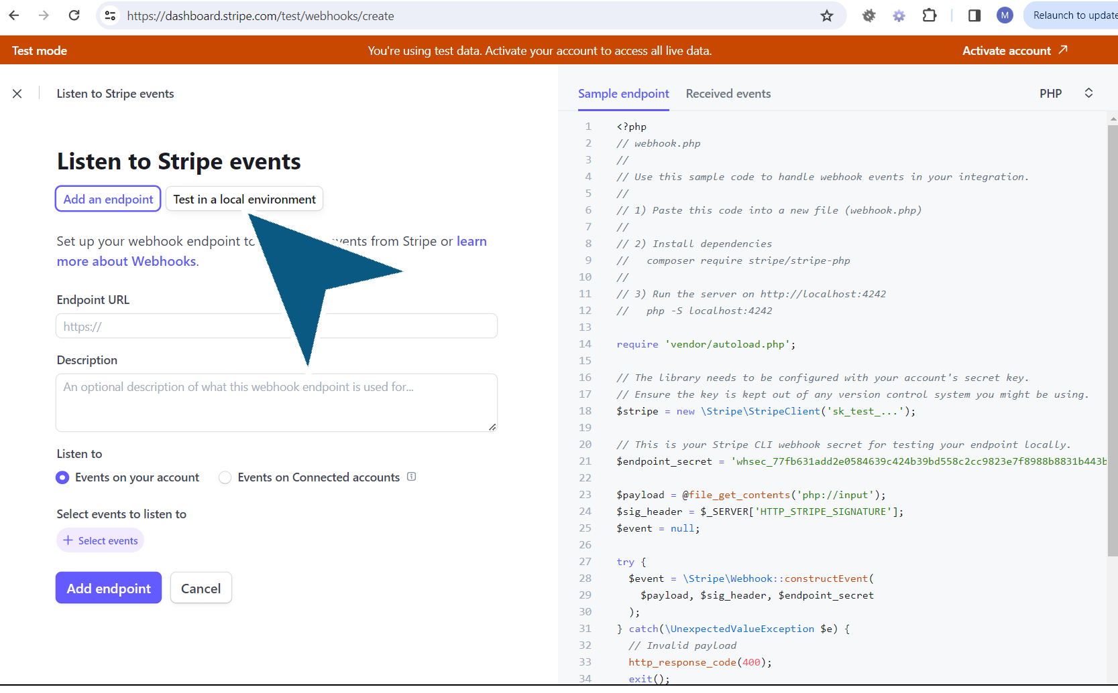

32. In the Listen to Stripe Events page,

Click on ‘Test in a local environment’.

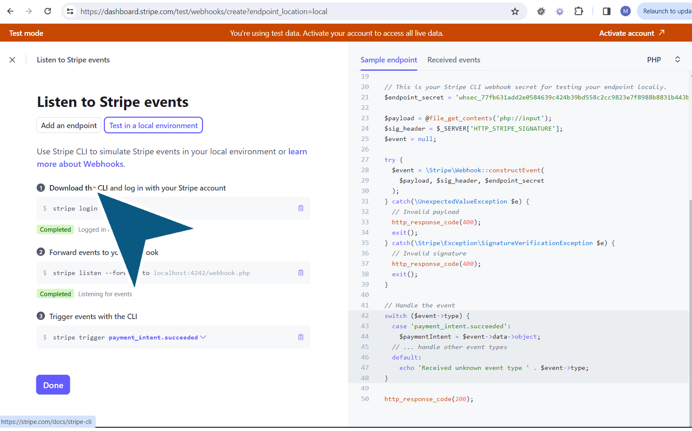

33. Then Click on ‘Download the CLI’.

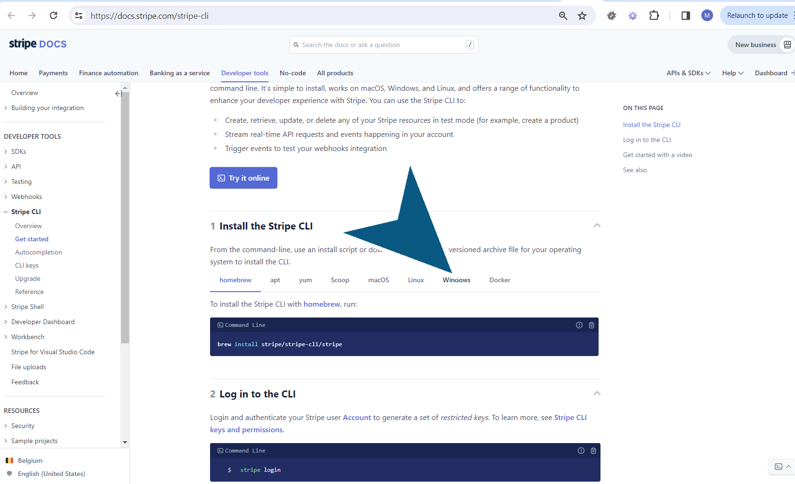

34. To install the Stripe LCI,

Click on ‘Windows’.

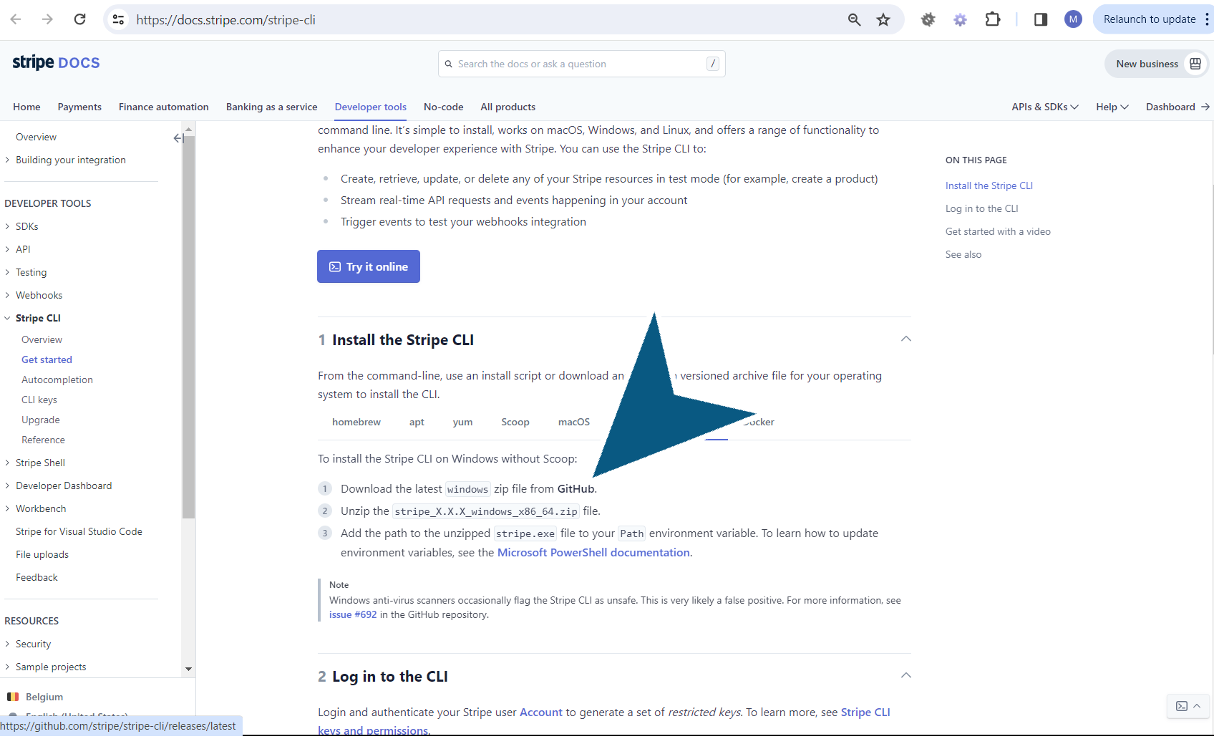

35. Click on ‘Github’.

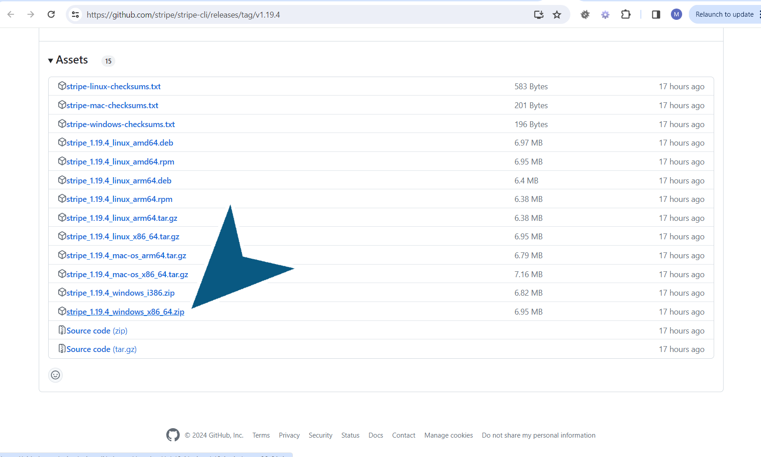

36. Scroll down and look for options to download on the operating system.

1. Click on the latest zip file ‘stripe_1.19.4_windows_x86_64.zip’ and download the file.

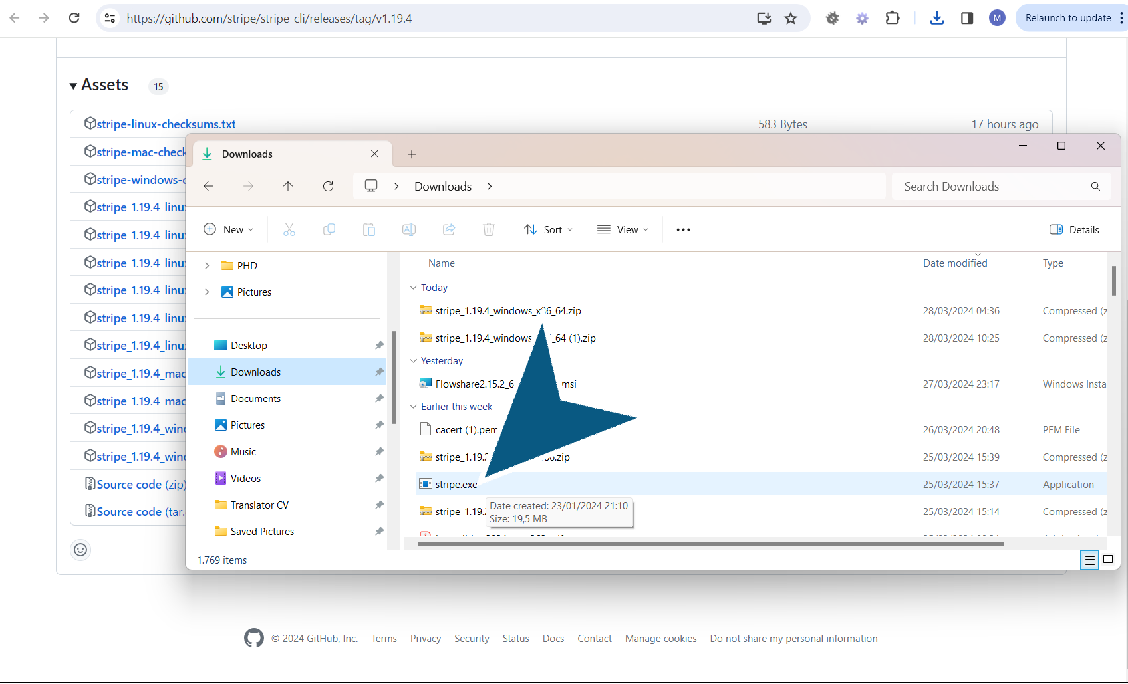

37.

Unzip the file to access the ‘stripe.exe’.

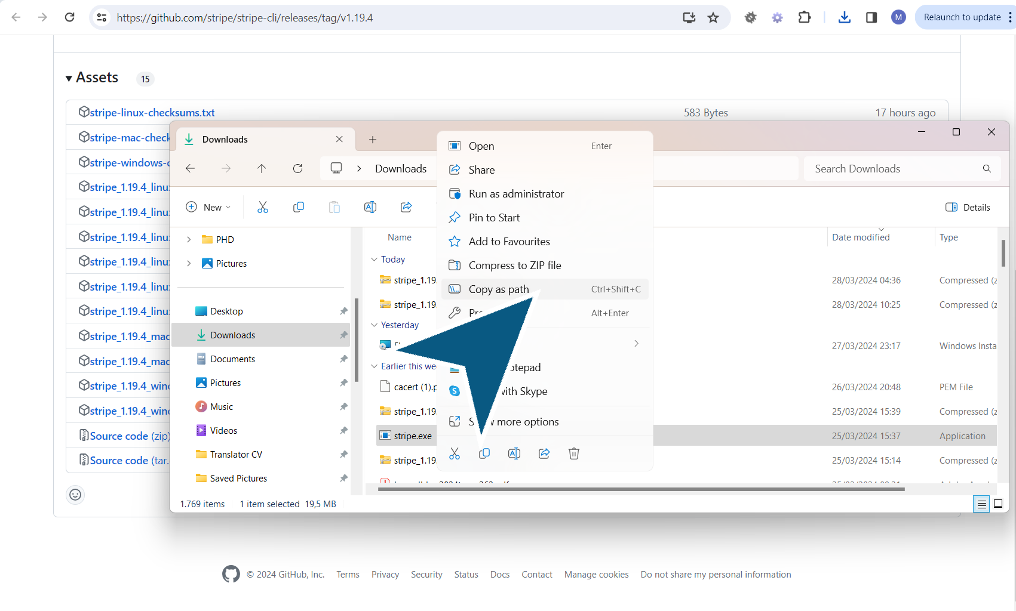

38. To log in into the CLI

Select ‘Copy as path’ from the menu when you click on the stripe.exe file.

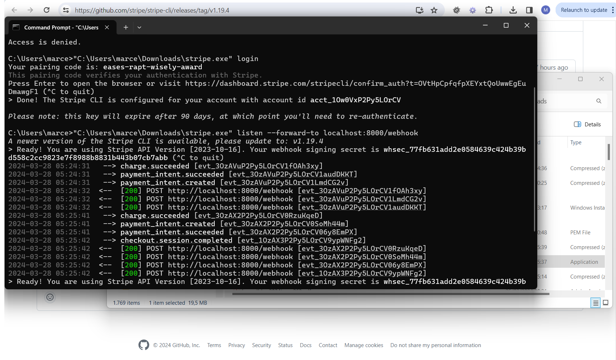

39. 1. Open ‘Command Prompt’.

2. Navigate to the path. In this example “C:\Users\marce\Downloads\stripe.exe”

3. Call the stripe.exe login -> “C:\Users\marce\Downloads\stripe.exe” login

4. Click ‘Enter’.

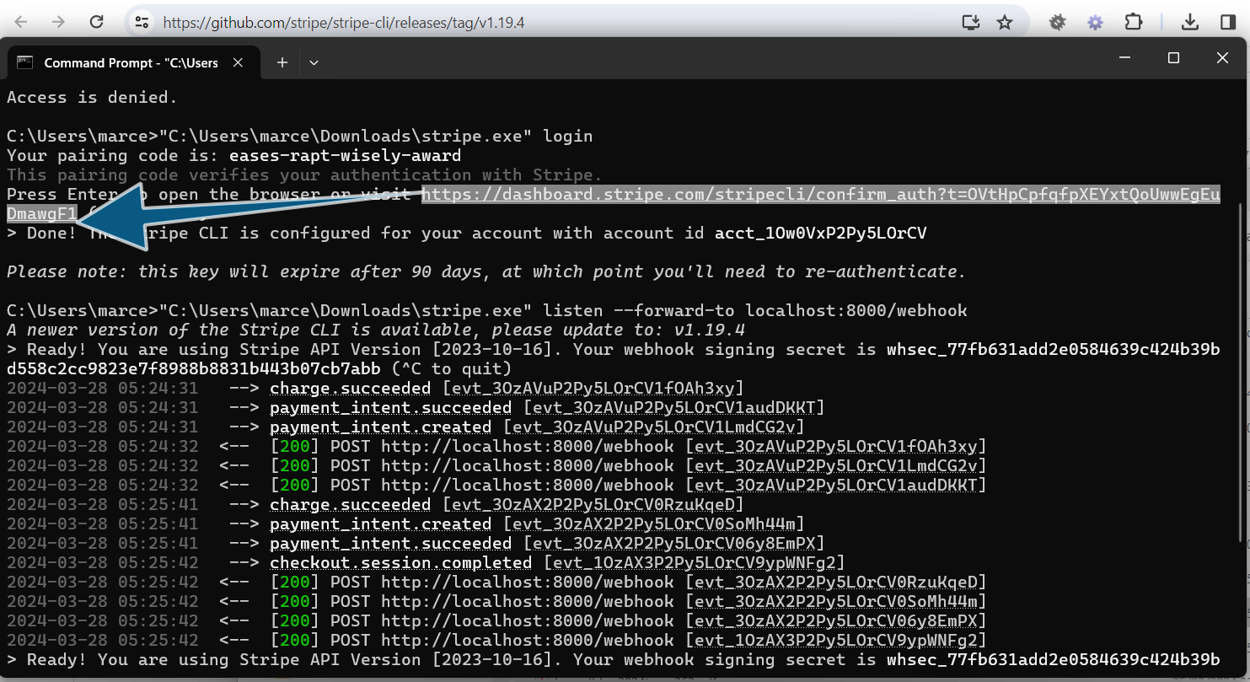

40. For the authentication with Stripe,

1. Copy the link that appears on the CMD and open it in the browser.

2. Check that the pairing code from the CMD is a match with the code on the browser and click on ‘Allow access’.

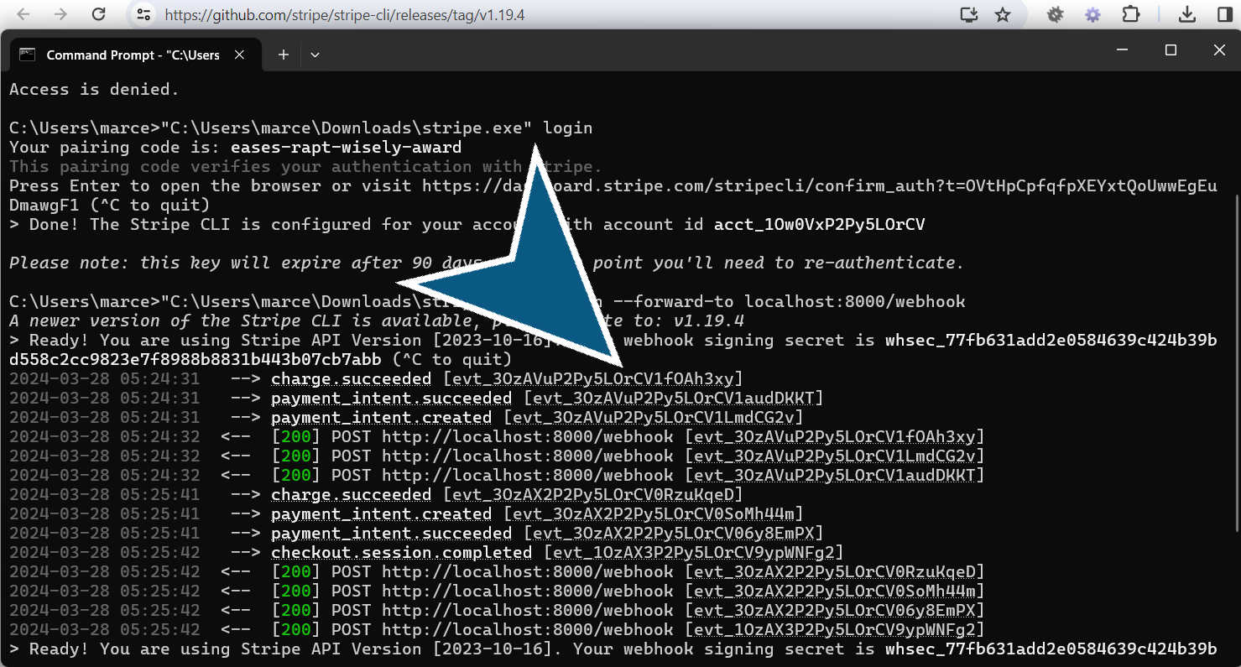

41. Press Ctrl+C.

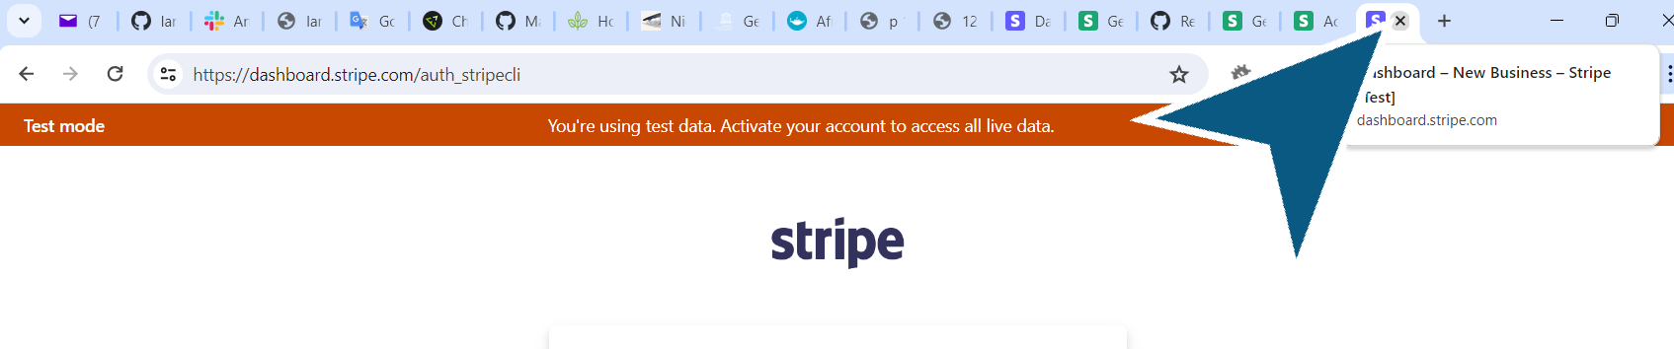

42. The view ‘Access Granted’ .appears.

You are authorized in the Stripe CLI.

1. Close the tab.

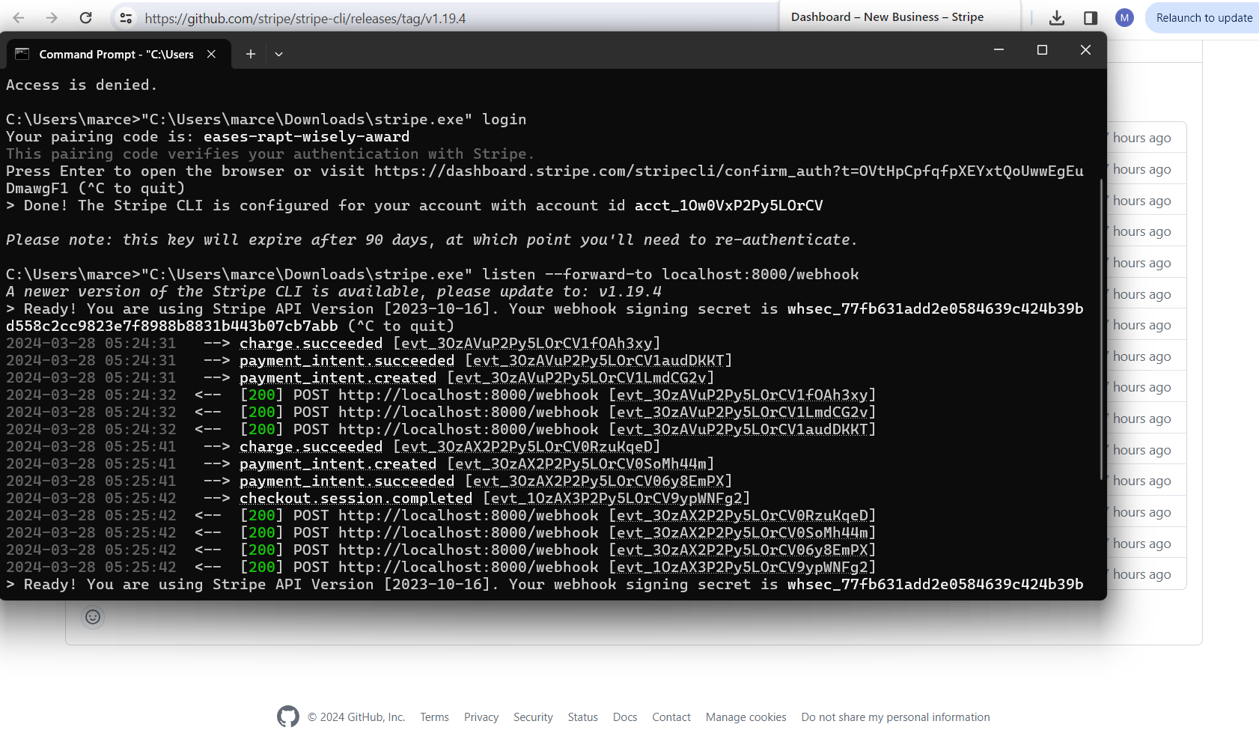

43. In the Command prompt page, you receive a message.

1. The Stripe CLI is configures for your account with your account id.

2. To forward events to the webhook,

Explanation: Whenever the checkout happens, Stripe cannot make a request to our server because it's locally hosted. But Stripe can listen to the webhooks and forward them to our local server.

3. Return to the Stripe docs at <https://dashboard.stripe.com/test/webhooks/create?endpoint_location=local>

4. Copy the code and change where you are listening to the webhook, in this case : “C:\Users\marce\Downloads\stripe.exe” listen --forward-to localhost:8000/webhook

5. Press on Enter. The webhook signing secret key appears, copy it and paste it in the .env file. It will be linked to the endpoint secret on the webhook function.

IMPORTANT: Don't close this CMD.

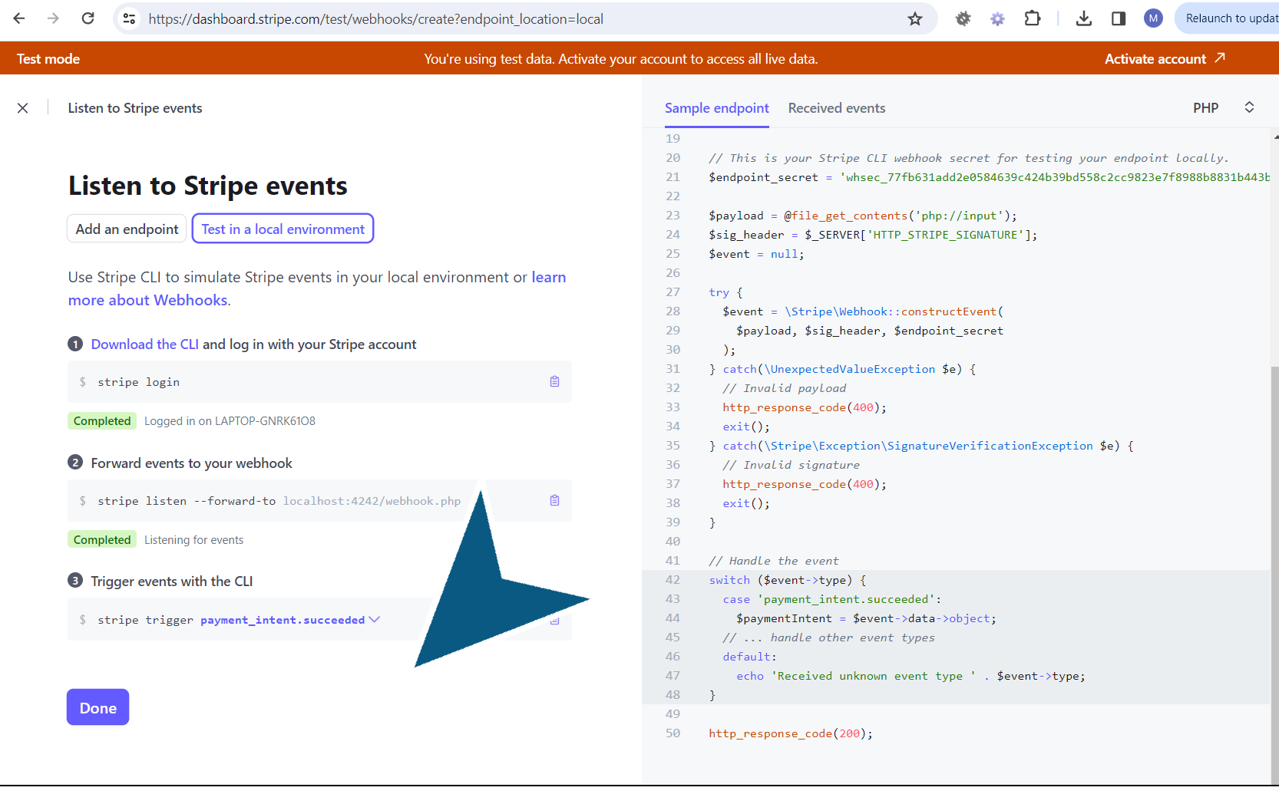

44. Trigger an event,

Explanation:To test if an event comes and want type of events.

1. Open another CMD.

2. Copy the path to the stripe.exe file

3. Copy the code to trigger payment_intent succeeded

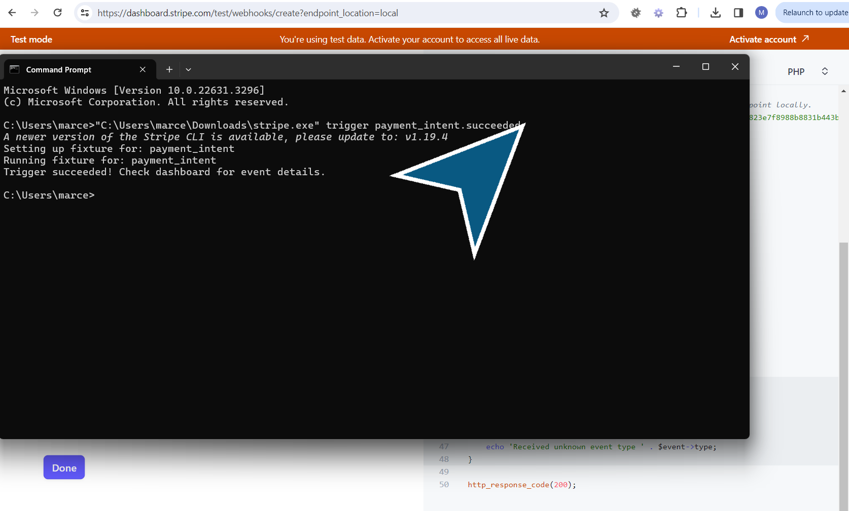

45. In the second ‘Command Prompt’.CMD that we have just opened,

1. Paste the path to the stripe.exe file

2. Paste the code to trigger the event

3. Click on Enter.

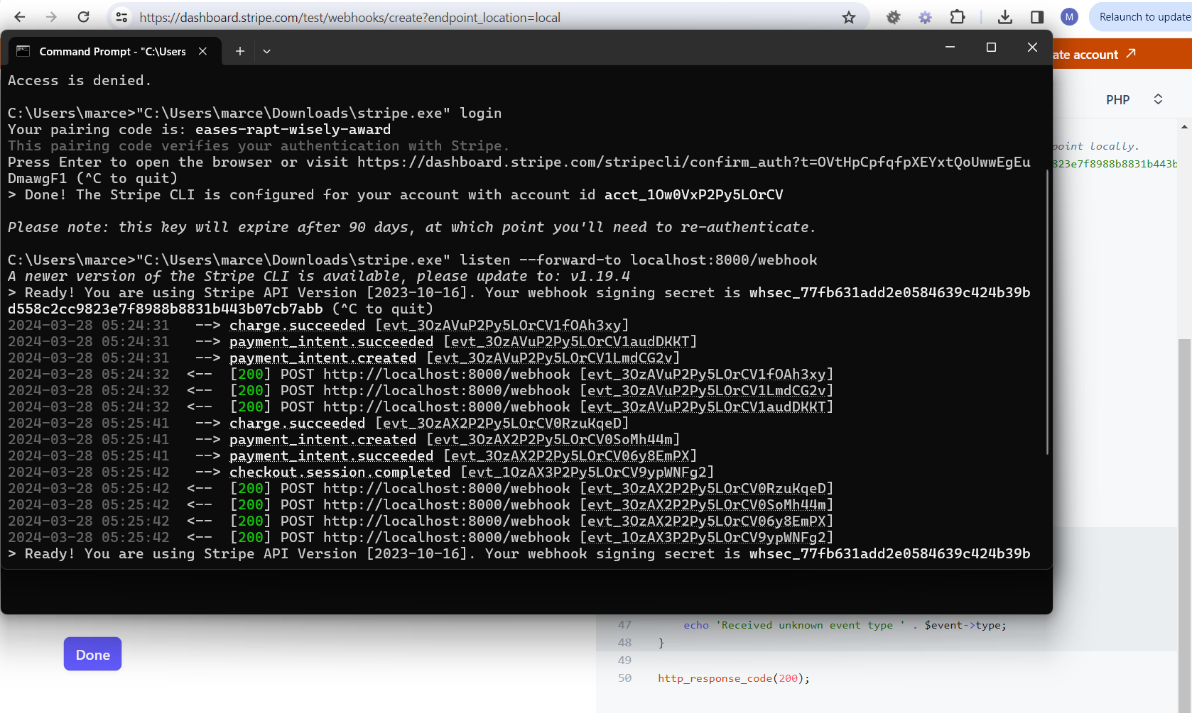

46. Open the first ‘Command Prompt’.CMD,

We see the different events, charge succeeded, payment intent created, payment intent succeeded and 3 request were made in to the webhook and return with the status 200. It also shows checkout session completed after implementing the webhook function.

1. If you ctrl+click on each of the events, you have access to the corresponding details. cf the following images.

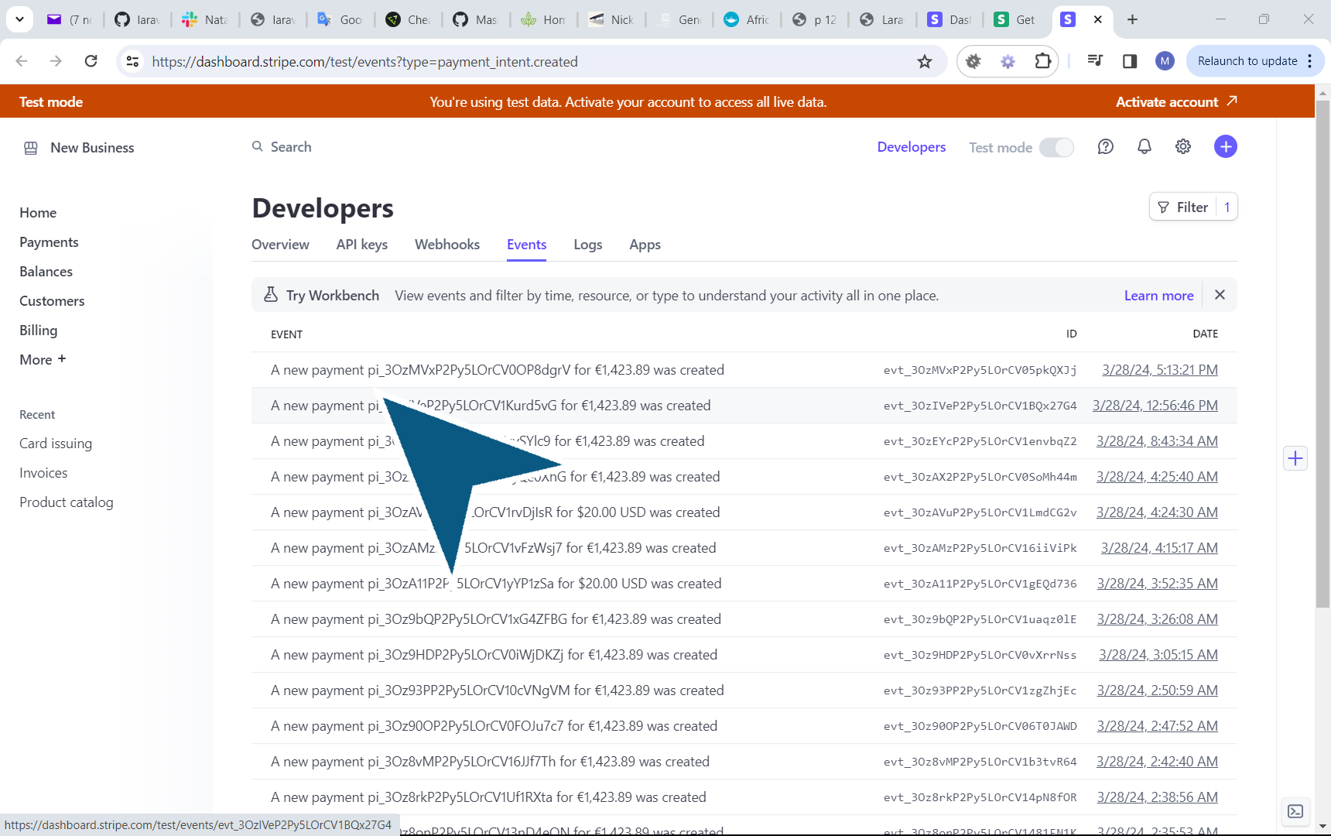

47. Payment intent

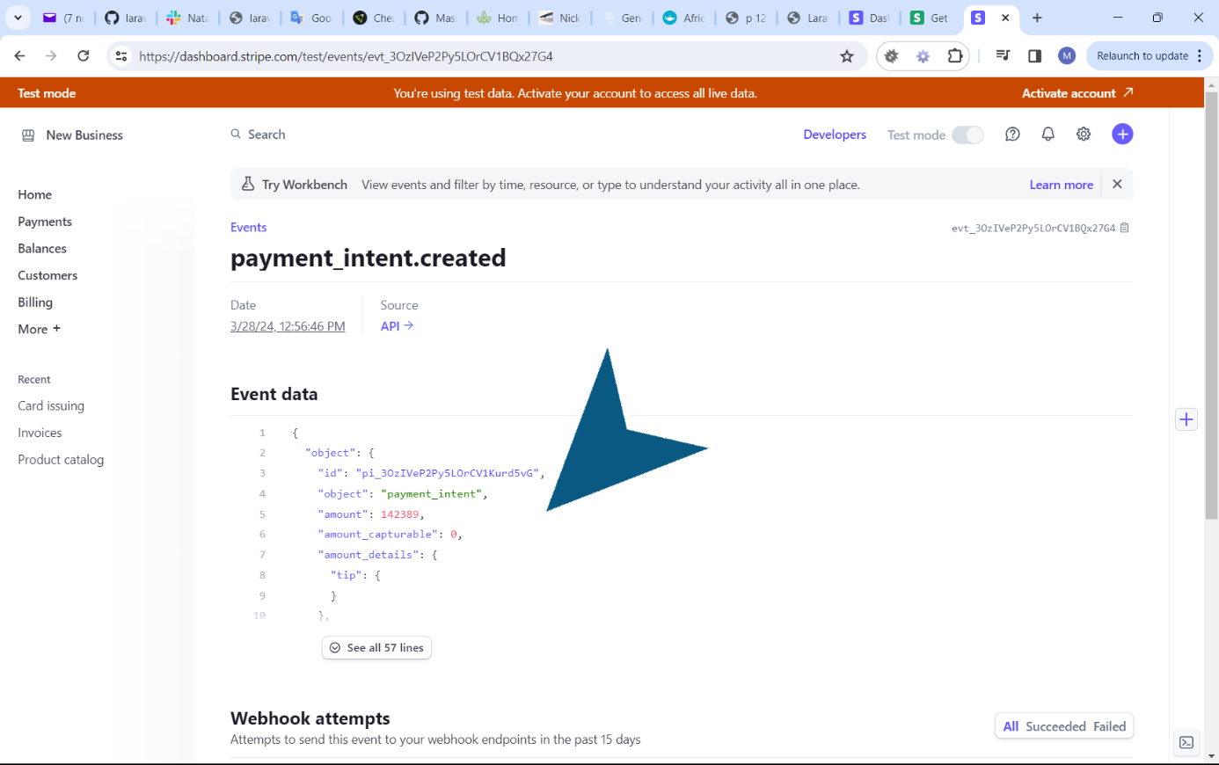

48. Payment intent created

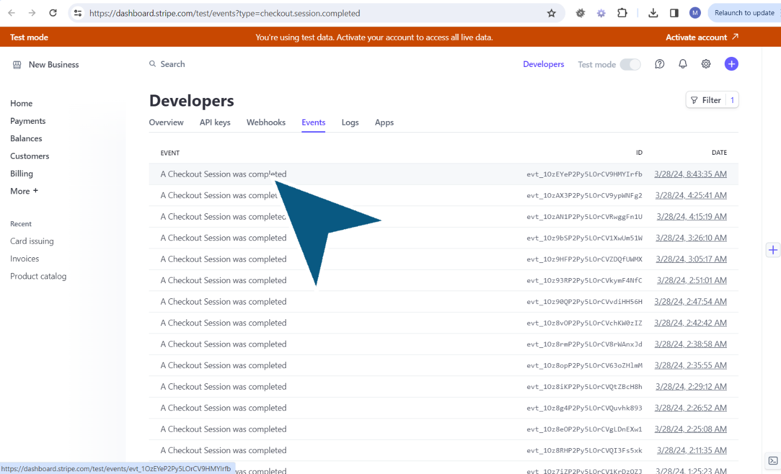

49. ‘A Checkout Session was completed’.

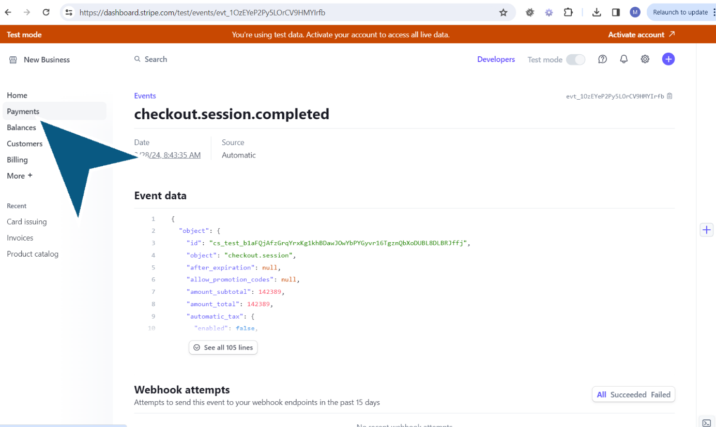

50. Click ‘Payments’.

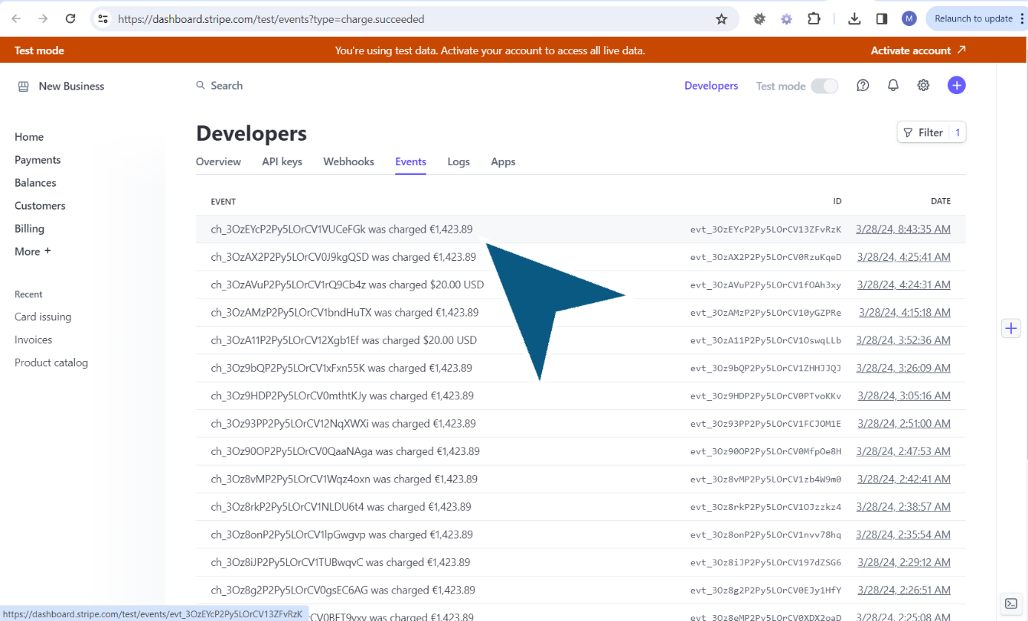

51. Follow the link: ‘ch_3OzEYcP2Py5LOrCV1VUCeFGk was charged €1,423.89’.

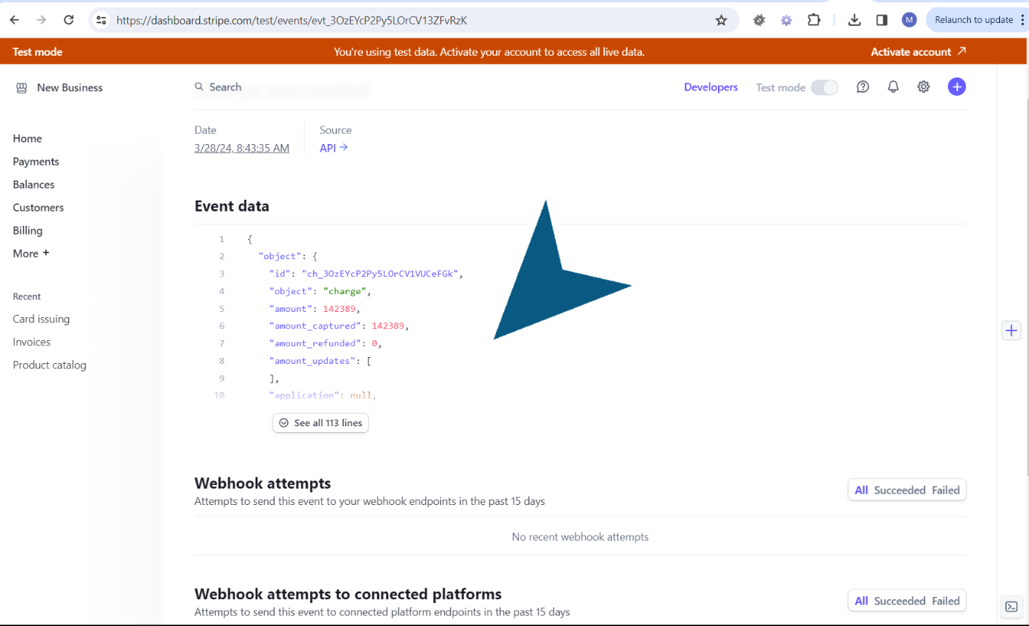

52.

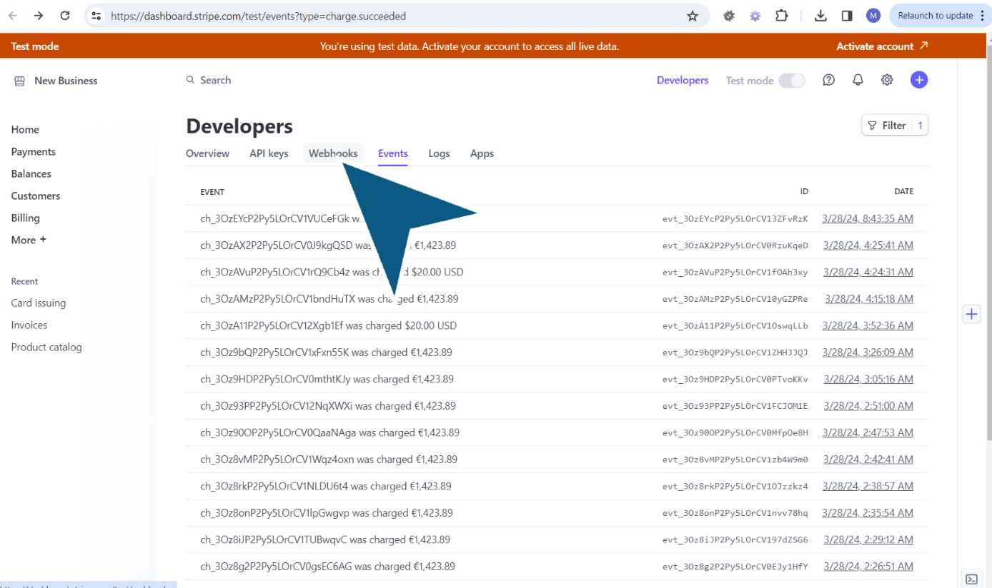

53. Click ‘Webhooks’.

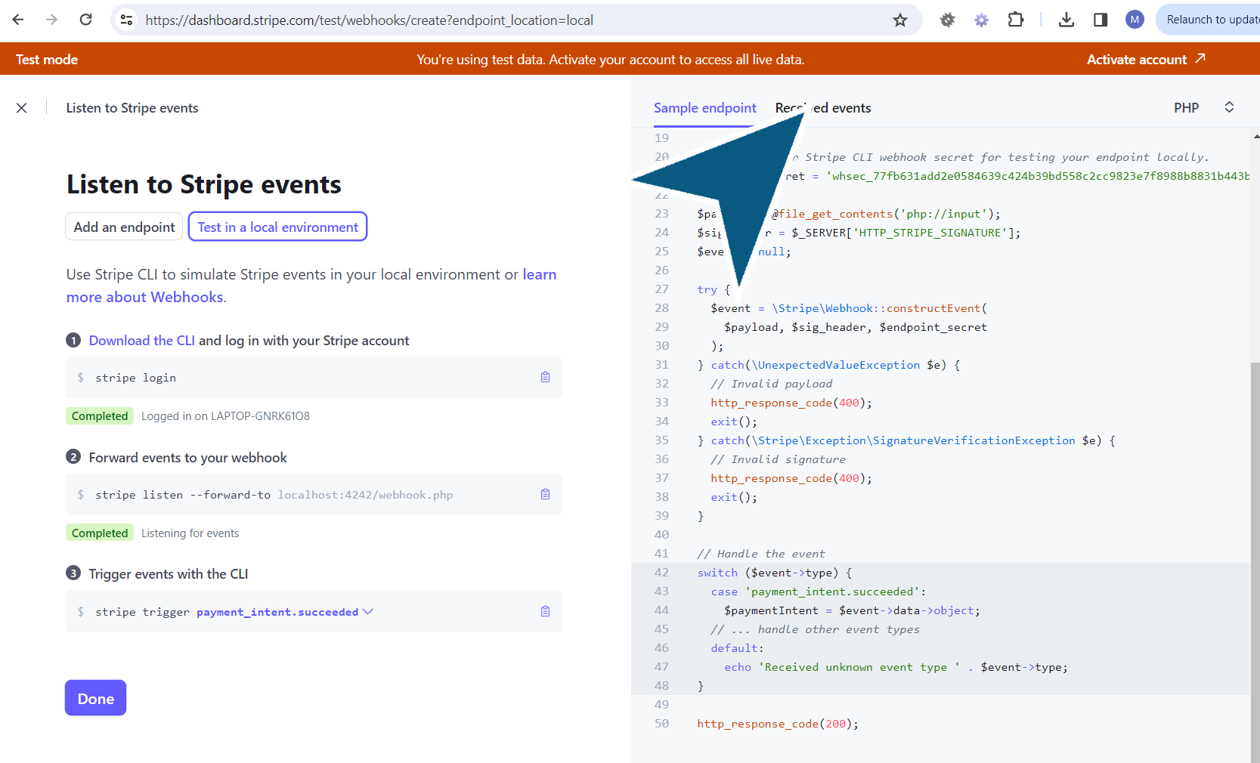

54. You can also have more details about the order and the checkout in the received events.

1. Navigate to ‘Add endpoint’ in the Stripe test dashboard.

2. Click on ‘Received events’.

# Test

55. Open the localhost page,

Navigate to the products page

1. Click on ‘Checkout’.

2. The Skipe checkout page appears,

Fill in the card info, specify the email, the cardholder name.

3. Click on ‘Pay’.

4. The success page appears with the success message.

When you look into the database, the status is paid. Even when the redirect to the success page doesn't appear, the status is confirmed by Stripe, thanks to the webhook. In production, an email can be sent to the user to confirm the payment.